P65Pas 0. 8. 9

Documentation – Optimisation and Synthesis

By Tito Hinostroza

REFERENCES

For the best understanding of this documentation, you should have knowledge of the following topics:

- SynFacilSyn Bookstore.
- Library P65Utils.
- CPU 6502.
- Assembly language of the 6502.

CONVENTIONS

In the development of this documentation, the following acronyms will be used:

RA .- Auxiliary records.
RP .- Stack records.
ORT.- Operation routines.
BOR .- Binary operation routine.
UOR .- Routine of unaria operation.
AST.- Abstract Syntax Tree.

Some terms will be used profusely within the documentation and could give rise to doubts. These terms are:

WR.- Work record. It can refer to internal CPU registers or memory positions in RAM.
Function.- Although the term could refer to functionality, when speaking in the context of functions in Pascal, it could also refer to procedures or methods of objects.
Encoding.- In the context of the compiler refers to generating machine or binary codex.
AST.- Abstract syntax tree, compiler.

Content

REFERENCES2
CONVENTIONS2
2INTRODUCTION6
2.1Compiler processes6
2.2The analysis7
3THE THEORETICAL FOUNDATION8
3.1Code Classification8
3.1.1Compliance code8
3.1.2Preventive Code9
3.1.3Unnamed code9
3.2Procedures9
3.2.1COROLARIO 110
3.2.2COROLARY 211
3.3Operations and Expressions11
4 RAM MANAGEMENT13
4.1Organization13
4.2Use of RAM13
4.2.1Work records (WR) 15
4.3Life cycle of variables and records16
4.4Requirement of memory17
4.5Memory for Variables17
4.6Memory for Records20
4.6.1Physical records. The TCpuRegister20 object
4.6.2Remory records21
5DECLARATION ELEMENTS23
5.1Contention declaration23
5.2Evaluation of constant declarations23
6TYPE OF OPERANDS AND STORAGE27
6.1The TEleExpress27 element
6.2 Operand type27
6.2.1Type otConst27
6.2.2Type otVariab29
6.2.3type otFunct29
6.3Store30
6.3.1storage stConst32
6.3.2settRamFix33 storage
6.3.3settRamVarOf34 Storage
6.3.4storage stRegister35
6.4Assignable Operations36
6.5Recome evolution37
6.6Storage on the BOR38
6.7Commonstring Limitations39
7CODING EXPRESSIONS40
8CODING FUNCTIONS41
8.1Types of functions41
8.2Normal user functions43
8.2.1Code generation43
8.2.2Call for functions44
8.3Normal system functions46
8.3.1Code Generation47
8.3.2Call for functions50
8.4INLINE System Functions51
8.4.1Code Generation52
8.4.2Call for functions55
8.5Summary of functions56
8.6Generating the code for the function body. 57
8.7Reference call57
8.8Parameter Optimization for Normal Functions58
8.9Optimization of the RTS63 statement
9OPERATION TUBS66
9.1Types of Operating Routines67
9.2Subexpresiones 67
9.3Representation in the AST67
9.4Calls to operating routines69
9.5Implementation of Operation routines71
9.6Review of Operating Routines73
10OPTIMIZATION75
10.1AST State. 75
10.2Construction modes76
10.3Optimation Processes76
10.4Detection detection77
10.4.1Unused functions80
10.4.2Variables, Constants and Unused Types82
10.4.3Units in used83
10.5Simplification of expressions83
10.5.1Assignment Answers84
10.5.2Preventive sentences85
10.5.3Process Call Answers86
10.6The problem of requirement detection88
10.6.1Require detection88
10.6.2System Function Requirements89
10.6.3The problem90
11SYNTHESIS92
11.1Code Generation Policy. 92
11.2Requirements93
11.3Creating variables93
11.4Code Generator Units93
11.5Using Records94
11.6Working Records (WR) 95
11.6.1Work records support96
11.6.2Working Records at the end of expressions97
11.7Use of Work Records97
11.8Conditional98
11.9Assembly Locks98
11.10Insembly Code Generation99
12DIRECTIVS102
12.1Custom Processing102
12.2The language of directives103
13SIMULATION105
13.1Simulator105

INTRODUCTION

Before starting with the description of the Compiler Optimization and Synthesis processes, it is advisable to review some concepts that will be useful later in this document.

Compiler processes

Within P65Pas, compilation, from reading the source code, to generating binary code, follows a number of fairly linear stages.

Optimized AST
AST full

The Analysis process, and the Syntax Tree (AST) are described in detail in the document "Documentation – Fundamentals and Analysis". The Optimization and Synthesis processes will be described in detail in this document, in sections 9 and 10.

Optimization works with the AST as its input and output. All their work consists of modifying, reordering and simplifying the AST in order to leave it ready for synthesis.

Synthesis uses AST as an entry point for code generation. It is not considered a binding stage, in the end, because code generation directly produces the executable code.

The Code Generator is distributed in a pair of units (GenCodBas and GenCod) that define higher-level classes that inherit from the innermost classes that implement the lexical, syntactic, and semantic parsers.

The analysis

It is the process that explores the source code, to obtain information from all the code that is accessible to the main program (considering files included, and units). It is performed by TCompMain.DoAnalyzeProgram().

The objectives of this phase are:
  - Detect program errors (Compile-time errors), mainly syntax errors.
  - Fill in the syntax tree Gather information about all elements of the program

This scan does not create variables, nor does it generate code, it only fills the AST with the syntactic elements of the entire program, including the elements of the units.

It is also at this stage that directives are executed.

The analysis process is described, in more detail, in the document "Documentation – Fundamentals and Analysis".

THEORETICAL BASIS

This chapter of the documentation discusses theoretical and technical concepts that have been used for compiler construction.

Code Classification

Considering the execution of the compiled code, we can classify the code into:
- Code Required.
- Conditional Code.
- Code not called.

Required code

The mandatory code is the one that, under normal conditions, will always be executed. Consider the following example:

begin
a := 1;
b := a + 1;
hacer_algo(a, b);
end;

This program is like a linear recipe of instructions, and will also generate a linear recipe of machine instructions.

To this code, we will call it, mandatory code.

A special case of mandatory code is the one that can be defined with the REPEAT structure:

begin
a := 10;
repeat
dec(a);
until a = 0;
end;

The code within the REPEAT is also mandatory code, because a REPEAT loop is always executed at least once.

In this way we can expand our concept of Mandatory Code, as that code that, in the course of the normal execution of a program, will be executed safely, at least once.

Conditional Code

Conditional code is the code that may or may not be executed, depending on certain conditions. It is the code that results from compiling the conditional instruction body.

As an example let's consider the following code:

begin
a := PORTB.0;
if a = 1 then
what goes here is conditional code
else
what goes here is, also, conditional code
end;
hacer_algo(a, b);
end;

The code within the body of the conditional structures (except in the REPEAT loop), may never be executed, but it is still compiled and takes up space within the device's memory.

Code not called

The code not called, is the one that will never be executed, because by the logic, of the program, it can be deduced, that the condition for execution will never be given. A case could be the following code:

begin
a := PORTB.0;
if 1 = 0 then
this block will generate uncalled code
end;
hacer_algo(a, b);
end;

Usually, the uncalled code corresponds to errors in the logic of the program, but it can also be created voluntarily, as a kind of comment.

The compiler should avoid compiling this code, because it is useless code, which only takes up memory, but in the current version of P65Pas, it will be compiled the same.

Note that the body of functions/procedures can also be mandatory/conditional/uncalled code, according to the location of the call points.

Procedures

Executable Pascal code is structured into procedures/functions and the main program.

Each procedure is an independent unit with its own variables, constants and even its own procedures.

From the compiler's point of view, each procedure is a separate unit of compilation.

Usually the execution of code within a procedure (or the main program) goes from the beginning to the end of the code, but there are cases when the linear flow of execution is broken:

- Within conditional structures
- In calls to other procedures/functions
- When the exit() statement is found.

An exit() statement in required code disables all code that exists after the exit() is called.

This can be expressed in the following AXIOM:

AXIOM OF EXIT:
"If in a procedure there is at least one exit(), in mandatory code, any subsequent code will not be executed"

The following example shows an exit() case in required code:

procedure simple: byte;
begin
a := 1;
exit(1);
end;

From the above axiom, the following corollaries can be deduced:

COROLLARY 1

COROLLARY 1:
"An EXIT statement, in mandatory code, is always the last valid instruction of the procedure/function"

Consider the following case:

procedure simple: byte;
begin
exit(1);
a := 1; //Non-executable code
end;

The additional code, which follows an exit() in required code, will never be executed and should not be compiled either. The best behavior for these cases is to generate a warning, but not compile.

In general, this situation constitutes an algorithm error and should be avoided.

COROLLARY 2
COROLLARY 2:
"There can only be one valid EXIT statement, in required code, in a procedure/function"

This corollary is deduced from the previous corollary. And while it may seem obvious, it's important to keep that in mind for code optimization cases.

Operands and Expressions

In the document "Documentation – Fundamentals and Analysis" both terms were explained and we know that they are related but their differentiation can be somewhat confusing.

It is understood as operating to that syntactic expression that follows the structure:


And the expressions, is a broader concept and are defined as the union of operands with operators:



But at the same time we know that in the syntax tree, both operands and operators are modeled in the same way (with only functions and operands). So the difference between Operands and Expressions is only syntactic, and not in modeling.

At many points in this document, we will say "Expression" or "Operating" interchangeably to refer to the same concept.

RAM MANAGEMENT

Organization

Within the architecture of the 6502, what you have is a simple CPU with access to a RAM limited to 64K:



The CPU of the 6502 only has an accumulator register that is used for all operations. Since only one register is handled within the CPU, it is necessary to use parts of the RAM as extended CPU registers.

RAM is linear, with addresses ranging from $0000 to $FFFF.

It is known that, to take advantage of the complete indexing possibilities, in the 6502, it is necessary to have some bytes on page zero. You could say that the CPU is not complete, if you do not have access to page zero.

Using RAM

In P65Pas, RAM will be used to store:

- Variables. Includes those defined in the source program and those that can be defined internally by the compiler.
- Work records (additional to A, X, Y or SR). They are used to perform calculations and return results.

This functional division in the available memory forces to implement a special manager that helps in the location of the memory to be used within the RAM. Something like a dynamic memory manager.

The following table summarizes the various types of variables and records:

MEMORY TYPE | USE | EXISTENCE
Variables | Storage of:  - Global variables.  - Local variables.  - Auxiliary variables. | From the first time it is used, until the end of the program.
Work Records | Internal calculations and results of functions.

Additionally, the CPU handles an internal stack on page 1. This stack is used for intermediate calculations. The compiler itself uses this stack very little because of the way it works.

Work Records (WR)

Work registers are the internal registers of the CPU (or specific positions of memory) that are used for intermediate calculations and for the evolution of results.

Work records have 2 functions:

- Serve as a means to perform the evaluation of expressions.
- Serve to return the result of expressions.

Since the 6502 has only one accumulator, it is often necessary to have additional records to handle data larger than one byte.

Therefore, some positions are reserved within the RAM memory to be used as additional "accumulator" registers.

The work logs defined for P65Pas are:

REGISTRATION | DESCRIPTION
A | PIC 8-bit accumulator. Main work record. It is always available.
H | 8-bit register. They are created on demand, usually when working with variables of type Word.
E, U | 8-bit registers. They are created on demand, usually when working with Dword-type variables.

Accumulator A is always created. The H, E and U registers will be defined by the compiler, only when the compiler deems it necessary, to save memory.

We said, that work records are created on demand. But how do you determine that they should be created?

The method is simple. The compiler, in its Analysis phase, goes through all source code and fills the AST. When it finds an operation that requires a work record (such as H), it will mark it as used so that in the Synthesis phase space is reserved in the RAM, permanently.

Work records such as H do not necessarily have to be used only to return the result of expressions, but can also be used as variables for intermediate calculations.

When additional records are required, auxiliary variables are usually created.

Lifecycle of variables and records

All RAM is used as a static zone, since in the current version of P65Pas, the same binary program is not allowed to create dynamic structures (such as recursion).

Each type of record or variable has a life span, that is, a time interval (associated with a code interval), in which its content is used by a specific routine and should not be used for other purposes.

The following diagram shows the use of RAM, for global and local variables, during the execution of a typical program.

Function 1

Function 3
Function 2
Local Variables

Global Variables

The shaded area indicates that this memory is used by the program.

Local variables, those that are defined within a procedure or function, have a life cycle at the level of the function where they are declared. Memory usage is reserved only when the function is executed, but outside of it, the main program could make use of that same memory area for other purposes.

Global variables, however, can maintain their value, with or without changes, throughout the program lifecycle. We say then that they have a life at the program level.

Let's now analyze the case of work and auxiliary records:

Section 2
Instruction 1

Instruction 4
Section 3
Work Records

Auxiliary records

The work and auxiliary records have a life at the level of instruction, that is, their use is restricted to the duration of an instruction. At the end of each instruction, their value loses meaning, and they are available to be used again, in the next instruction.

An instruction can be a structure or an expression. Within an instruction, records have even a more complex lifecycle (Section 6.4).

Memory requirement

Within the Synthesis process, there are frequent memory requirements. All these requests are met by the memory management routines, declared in the GenCodBas_PIC16 unit. At a lower level, the memory management routines of the P6502Utils are used:

- TPIC16. GetFreeByte()
- TPIC16. GetFreeBytes()

All memory requests are made to the "pic" object of the TP6502 class, which is part of the P6502Utils library. The requests arrive by two points (for variables or registers), to the TPIC16 object, but they do not intersect, because once a position for memory is obtained, it is marked internally, as used, within the TPIC16 object.

Memory manager for variables

TPIC16

Memory manager for registers

So it is possible that both variables and registers share memory (in different directions) without problems. But because the System drive (which contains the WRs), is the first to be compiled, the WRs will be the first to be assigned, so that they occupy page zero, as expected by optimization.

Memory for Variables

To reserve space in RAM, for program variables, the TGenCodBas_PIC16 method is used. CreateVar(), defined in the "GenCodBas_PIC16.pas" file. This method uses the routines of P6502Utils to request space from RAM, therefore, the allocation will be made linearly, starting at the low positions (starting at $020, or $00C, depending on the device).

Requests to create variables are made only when "VAR" declarations are found in the source code.

The memory allocated to the variables, are allocated only once and are immovable, until the end of the program. This is only true for global variables.

The compiler tries to optimize the memory to the maximum, using the minimum space required for the program variables or their internal data.

The size of the variables, by their type is:

VARIABLE TYPE | SIZE
Boolean | 1 byte
Byte | 1 byte
Char | 1 byte
Word | 2 bytes
DWord | 4 bytes

The following figure shows how the variables defined in RAM appear from a simple source code:

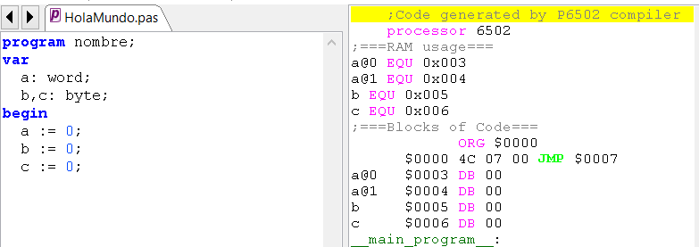

Variables of type word, are stored as two consecutive bytes and with the lowest weight byte, first.

The internal variables of the compiler appear in the same way, inside the RAM, only they are automatically generated by the compiler. As much as possible, you avoid having to use the internal variables, so space will only be reserved for them when necessary.

The following figure shows how the compiler generates three internal variables for use in compiled code routines:
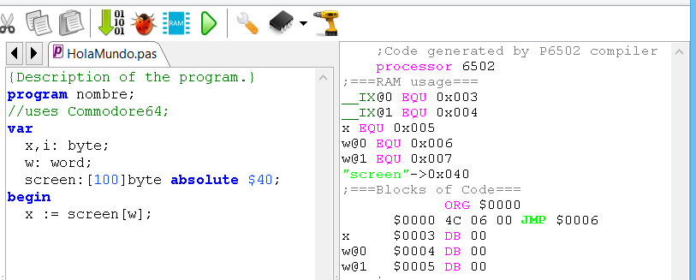

Memory for Registers

The records, within P65Pas, refer to compiler variables, representing:

- Physical registers, which exist within the CPU, such as accumulator A. They are implemented by using the TCpuRegister object.
- In-memory registers, which will be used as auxiliary REGISTERS of the CPU (The 6502 is limited in internal registers). They are implemented as simple variables.

Physical records. The TCpuRegister object

The physical registers of the CPU are modeled using the "TCpuRegister" class. Its definition is:

TCpuRegister = class
public
used : boolean; //Indicates whether it is used.
end;

Because the 6502 only has Byte-sized records, only the TCpuRegister object is enough. Also as there is only one general purpose register, A, the utility of TCpuRegister, in this compiler is almost null and could be dispensed with. It remains a utility, for when compilers with multiple records are created.

An internal CPU register should always be available to implement operations, but it could be busy. Either way, it will always be available at the end of an expression (Statement):

The following diagram shows the lifecycle states of a common record between the execution of instructions:

Sense of execution

Section 2
Instruction 1

Instruction 4
Section 3
Record created

Record used

The shaded area indicates the moments in which the record is used. As its value does not persist after an instruction we can say that its life cycle is at the level of instruction.

Is what an instruction is well defined?

Initially, the TCpuRegister object was also used to represent in-memory registers (such as H, U, and E), and had a more complex life cycle, but in the new compiler design, in-memory registers are handled as simple variables, which simplifies lifecycle management and optimization, as well as allowing access from the main program to their values.

In-memory registers

Internal CPU registers are scarce on the 6502. That is why memory zones are used to increase the working capabilities of the compiler.

To date, additional records, created in RAM, are:

Registration | Guy | Number of variables | Use
H | Byte | __H | High byte for values of type Word. Temporary storage.
And | Byte | __E | Byte2 for values of type Dword. Temporary storage.
In the | Byte | __U | Byte3 for values of type Dword. Temporary storage.
IX | Word | __IX | Index for stRamReg storage operands (See section 4.8)

For optimization reasons, it is convenient to create these records on page zero.

The IX record, however, is required to be created on page zero, because it is used to implement indirect addressing.

These registers are handled as the internal registers of the CPU, that is, to facilitate the calculations and handling of values. The only difference is that they are mapped in memory, which can be convenient (and "Necessary" in the case of the 6502), for indexed addressing management.

Because these records are handled as variables, their memory creation and allocation rules follow the same rules as that of any variable. Thus, therefore, they will only be created in memory if they are used.

As a consequence of being variables, these records can also be accessed from the main program, providing access to additional functionalities of the compiler, although under normal conditions, it should not be necessary to access these variables.

To access these variables, their name is used as variables, which is indicated in the table above.

The following code shows how the H record is accessed from any program:



ELEMENTS OF DECLARATION

Declaration elements are the elements that are created in the AST, to represent the declarations of variables, constants, types, and procedures.

As these elements have been described in the document "Documentation – Fundamentals and Analysis", here we will go into more detail on the aspects related to optimization and synthesis.

Statement of constants

Constant declarations are represented in the AST with an element of type TEleConsDec.

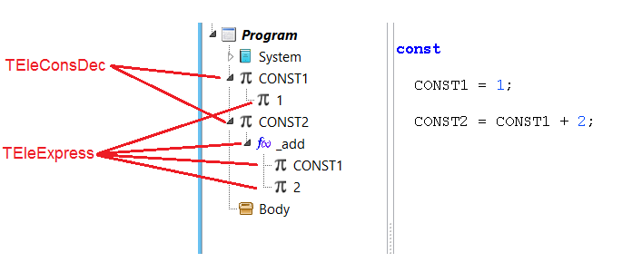
However, declarations must in turn contain at least one TEleExpress node.

For direct cases, such as CONST1 in the figure, the TEleExpress node will be a simple constant, but for more complex cases, such as CONST2, the TEleExpress node will be an expression, with child nodes, as an expression found in common instructions, as described in section 7.

Evaluation of constant declarations

The last process of the constants is the evaluation and is carried out in the Optimization process. Evaluating a constant implies obtaining its final value, evaluating the expressions that define it, if necessary.

To control whether a constant is evaluated (and its value can be safely read from "value"), the flag "evaluated" is used:

TEleConsDec = class(TxpEleCodeCont)
//Element type
type: TEleTypeDec;
evaluated: boolean;
//Constant value
value : TConsValue;
constructor Create; override;
end;

An important rule would be:
You should never read the value of a constant if its "evaluated" field is in FALSE.

Simple definitions such as "CONST1 = 2" are evaluated directly in the analysis process. The code can be read in TCompMain.CompileConstDeclar():

procedure TCompMain.CompileConstDeclar;
...
cons := AddConstantAndOpen(consNames[0], typNull, srcPosArray[0]);
if HayError then exit; //Can be duplicated
you must follow a constant expression that does not generate code
init := GetExpression(0);
if HayError then exit;
cons.typ := init. Typ; //Update constant type.
if init.opType = otConst then begin
//A simple value. We can initialize the constant.
cons.value := init.value;
cons.evaluated := true;
end;
//Other types (no stConst) will be evaluated later.
TreeElems.CloseElement; //Close constant.
...

More complex expressions such as "VAL = CONST1 + 3;" will generate an expression of type "otFunct" and will not be evaluated in TCompMain.CompileConstDeclar(), but will be left for the optimization process.

The optimization routine that evaluates constant declarations is EvaluateConstantDeclare(). There you can see that calls are made to ConstantFoldExpr(), which finally calls codSysInline() which is the same routine that is used to generate code:

procedure TCompiler_PIC16. ConstantFoldExpr(eleExp: TEleExpress);
...
begin
if eleExp.opType = otFunct then begin
//It's an expression. There should be a function
funcBase := eleExp.rfun;
if funcBase.callType = ctSysInline then begin
//Only INLINE functions can returns constants.
if funcBase.idClass = eleFunc then begin
//It's the implementation. No problem.
//Process all parameters.
for ele in eleExp.elements do begin
parExpr := TEleExpress(it);
ConstantFoldExpr(parExpr); //Try to evaluate constant.
if HayError then exit;
end;
funcBase.codSysInline(eleExp); //We don't expect this generates code.
//Check if we can simplify
...
end else begin
//In Normal subroutine, we scan for parameters
//Process all parameters.
for ele in eleExp.elements do begin
parExpr := TEleExpress(it);
ConstantFoldExpr(parExpr); //Try to evaluate constant.
if HayError then exit;
end;
end;
end else if eleExp.opType = otConst then begin
...
end;
end;

Constant expressions will appear as a common expression, an operand of type "otFunct". The idea is that these expressions only return constant values.

Note that the ConstantFoldExpr() routine also does a simplification job after evaluating an expression. This simplification consists of eliminating the child nodes, if the result of the expression is a constant or a variable. In this way the consistency of the syntax tree is maintained, where by definition, the constants and variables do not have child nodes.

In this way, an expression like:

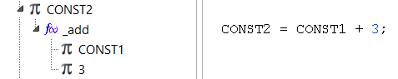

After going through the evaluation process, it would appear as:

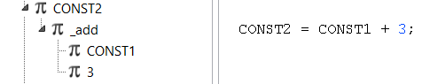

But, now the node "_add" is a constant and should not have child nodes, that's why CodeEleExpress()performs a cleaning of the child nodes, when the result of a function is a constant, so that the expression would look like this:

Which is equivalent to a simple constant statement.

The same simplification process applies to the case where the expression/function returns a variable.

TYPE OF OPERANDS AND STORAGE

Elements that are of the TELeExpress class are considered operands.

The TEleExpress element

We know that within P65Pas operands are special cases of expressions and that expressions are modeled as functions and operands and that all of them are represented as objects of the TEleExpress class (For more information see the document "Documentation – Fundamentals and Analysis").

An operand is defined by its storage and by its type.

Operand type

To determine whether the expression or operand element (TEleExpress object) is a function, a variable or a constant, we must resort to its "opType" field:

TEleExpress = class(TxpElement)
public
opType : TopType; //Operand type.
Sto : Tstorage; //Storage of the value (memeory, register, value)
Typ : TEleTypeDec; //Data type for the operand.
value : TConsValue; //Constant value, when storage opType is otConst.
rvar : TEleVarDec; //Reference to variable, when opType is otVariab.
rfun : TEleFunBase; //Reference to function when opType is otFunct.
...

The listed TopType, is quite simple:

TopType = (
otVariab, //Operand is variable. Allows read/write.
otConst, //Operand is constant. Only for read.
otFunct //Operand is a function/method or expression result. Only for read.

The difference between these types of operands has more to do with the allowed operations (read/write) than with the way the values are stored. Therefore, this type is important in the analysis phase.

The type of an operand is related to how its value is stored (For example, variables are usually stored somewhere in RAM), which is defined by the "Sto" property of TEleExpress. This storage is important for the synthesis phase.

otConst type

They are operands that represent the constant elements within the programming language. These can be:

- Literal constants, such as: 123, $FF, 1.0 or 'Chain'.
- Named constants, defined in the CONST section.

All of these constants have a type, as do variables.

Operands of type otConst are the easiest to work with because the value they contain is known in advance (almost always) and it is not necessary to save this value in RAM or registers, but the compiler keeps it in its own memory and can recover this value at any time and use it to generate the code efficiently.

ACCESS

Syntactically, otConst operands can only be used as read.

So, for example, the following code would generate an error:

const N = 2;
...
N := 3;

STORAGE

The allowed storages for otConst operands are:

- stConst
- stRamFix

The normal, and what would be expected, would be to always use the stConst storage for all constant operands, by the way it is defined.

The stRamFix case is a special case provided for constants that need to be stored in memory, such as the case of arrays or strings, on which some operation has to be performed that accesses part of the constant but cannot be resolved at compile time. Examples of this type would be:

'String example'.substr(i,2)
arreglo_constante[i]

Logically, the following expressions can be resolved at compile time and would not require using stRamFix storage for the string or array:

'String example'.substr(3,2)
arreglo_constante[3]

These types of expressions, however, are not supported in the current version of the compiler, but it is expected in the future to implement them in this way.

At the moment, all otConst operands use stConst storage.

It should be added that although it seems a strange case the stRamFix for constants, it should be considered that finally all the constants must be accessible to the CPU (although it is not necessarily from RAM), because the stConst operands are loaded into registers or RAM before using them in code generation.

Type otVariab

The type of otVariab operand is easy to understand because it is related to elements called "variables" within programming languages.

ACCESS

Syntactically, otVariab operands can be used both as read and write:

var n = 2;
...
n := 3 + n;

STORAGE

The storages allowed for otVariab operands are varied:

- stRamFix
- stRamReg
- stRamVar
- stRegister
- stRegistA
- stRegistX
- stRegistY

otFunct type

The otFunct type can be understood as the result of expressions (such as x+y) or as the result of functions (such as min(x,y)), and which are usually stored in microprocessor registers, rather than RAM.

It is said "usually" because in reality, the 6502 has so few internal registers that additional RAM memory is usually used to fill the lack of internal storage.

In any case, work records (WRs) will always be used for the return of results.

ACCESS

Syntactically, otFunct operands can only be used as a read:

var n = 2;
...
n := 3 + n; //The expression (3+n) is "otFunct" and is read-only.
3 + n := 1; //The expression (3+n) cannot be written.

STORAGE

The allowed storages for otFunct operands are:

- stRegister
- stRegistA
- stRegistX
- stRegistY

Storage

The issue of storing the value of a TEleExpress, is another classification, and is defined with the field "Sto", which is an enumerated TStorage, defined in the unit XpresElemP65:

//Operand value storage. Hardware dependent.
TStorage = (
stNone, //Without storage
stConst, //Constant value
stRamFix, //In RAM. Address constant and defined.
stRamVarOf, //In RAM. Address obtained reading a variable and offset.
stRamReg, //In RAM. Address allocated in Work Register.

stRegister, //In default registers.
stRegistA, //In register A. Only for byte-size variables.
stRegistX, //In register X. Only for byte-size variables.
stRegistY //In register Y. Only for byte-size variables.
);

Storage precisely defines how the value of an operand will be accessed when running inside the target CPU. Therefore it is a concept that is quite linked to computer hardware, and is free to be defined in accordance with the design of the compiler.

Additional storages could be EEPROM memory or FLASH memory, if the device supports it.

You could also define fewer storages if you wanted to simplify the compiler. For example, you could delete all log storages and store all results in variables, but this way of working would not generate optimized code.

The storage (field "Sto") of an operand/expression, is an independent concept, but related to the type of operand (opType field).

The following table shows the allowed storages for the 3 types of operands:

Type of Operand | Access | Storage | The value is stored in | Example
otVariab | read/write | stRamFix  stRamVarOf  stRegister  stRegistA  stRegistX  stRegistY | RAM  RAM  Registration/RAM  Registration  Registration  Registration | x := a;  x := a[x];  x := func(a,b);  x := registerVar;  x := registerVar;  x := registerVar;
otConst | read | stConsta  stRamFix | Compiler  RAM | c = 1234;  c = 'Hello';
otFunct | read | stRegister  stRegistA  stRegistX  stRegistY | Registration/RAM  Registration  Registration  Registration | x := func(a);  x := func(a);  x := func(a);  x := func(a);

Variables support the most storage and share some of these with otFunct operands. Therefore, seeing storage alone is not enough to elucidate whether an element is a variable or the result of a function/expression.

For each storage, TEleExpress has special fields to work with the operand. For example, if it is a numeric constant, its value is read with the field "value".

The stRamVarOf storage was created solely to support arrays and pointers. If the language to be implemented does not have these structures, this storage can be dispensed with.

stConst Storage

An Operand with stConst storage refers to a constant, and represents a value of any type, that will not change during program execution.

The expressions that are handled as stConst are:

Literal Constants | They are the ones that are defined in the same expression. For example:  123  True  $3FFFF  'A'
Constants with identifier | They are the identifiers that have been defined as constants, by means of a declaration, for example:  CONST  VALOR_UNO = 1;  CAR_A = 'A';
Constant expressions | They are the expressions that result in constant values, for example:  1+1  (VALOR_UNO + 5)  $00 and x

All of these cases are represented as a "stConst" storage operand, and behave similarly within the compiler.

The compiler will always try to handle expressions from the simplest storage, which is "stConst", so if you can simplify expressions to a constant type (such as "$00 AND x"), even when they are very complex, it will.

In general, it can be said that constants are not stored in CPU memory, and are only loaded with their literal value when they are called in expressions.

Consider, for example, the following underexpression:

x + VALOR_UNO

The constant VALOR_UNO, does not occupy memory and is only loaded into the registers when it is required to operate on it.

However, there are cases where a constant will be loaded into memory as an ordered structure, such as the case of a constant array, when accessed through a variable or expression.

An example of this case is the following code:

arreglo_constante[i]

Here, even though "arreglo_constante", is a constant, it will require that a structure be created in memory (it can be RAM or FLASH) and code, which according to the value of "i", returns an item of the arrangement.

Constants of this type will have stRamFix storage.

ACCESS FIELDS

GUY: | It reads in the TEleExpress.Typ field.
VALUE: | It reads in the TEleExpress field. value.

"Typ" is necessary because "value" is only a container of values, but does not indicate the type of data.

In this case, TEleExpress behaves as a container for the possible values of a constant.

stRamFix Storage

Operands with stRamFix storage mainly represent the common variables that we handle in a program. They are defined as values that are stored somewhere (fixed) in the RAM of the microcontroller or microprocessor.

StRamFix operands can be:

Common variables | Variables of any kind, such as:  - Var1  - variable_larga  These variables have a fixed direction determined when reserving space in memory.

ACCESS FIELDS

GUY: | It reads in the TEleExpress.Typ field.
VALUE: | It is read in ram at the appropriate address.
ADDRESS: | It is read from TEleExpress. rvar. Addr

The "rvar" field is used by a TEleVarDec object, which is a type of element in the syntax, and which is the class that represents a variable.

The operand includes a reference to a TEleVarDec element, and through that reference, you can access its address and additional fields/methods of the variable. The reference implies that TEleExpress is not the container of the variable, but only saves the reference to an existing variable (of any type). In other words, TEleExpress does not create or destroy variables, only referencing them.

The final physical address will be stored in TEleExpress. Add.

In general, stRamFix storage also does not take up space in system memory, and are only accessed when called in expressions.

stRamVarOf Storage

Operands with stRamVarOf storage mainly represent variables whose final direction is not known in advance, but must be calculated based on the content of a variable and an offset.

This storage was defined to facilitate the deployment of pointers and fixes.

The stRamVarOf operands can be:

Variables with fixed calculated direction. | How:  - x.campo  - arrangement[5]  The direction of these variables is not direct but can be calculated, but requires that it be calculated by a base direction and a displacement.
Variables with direction to be calculated. | How:  - arrangement[x]  - fix[x>>2+1]  - p^  The final direction to which the operand refers must first be calculated.

Commonly, in BOR, stRamVarOf is converted to stRegister storage, to work on them.

Only in the case where the reference is on the left side of an assignment, the pure reference is required, because here it is about changing the value of a referenced variable:

p^ := 5;

Because of this, assignment TALs do not simplify the operation when they are on the left side.

ACCESS FIELDS

GUY: | It reads in the TEleExpress.Typ field.
VALUE: | It is read in ram at the appropriate address.
ADDRESS | If mem lee[TEleExpress.rvar.addr + offset]

The "rvar" field is used by a TEleVarDec object, which is a type of element in the syntax, and which is the class that represents a variable.

The operand includes a reference to a TEleVarDec element, and through that reference, you can access its address and additional fields/methods of the variable. The reference implies that TEleExpress is not the container of the variable, but only saves the reference to an existing variable (of any type). In other words, TEleExpress does not create or destroy variables, only referencing them.

In general, stRamVarOf Operands also do not take up space in the system memory, and are only accessed when they are called in expressions.

stRegister Storage

An Operand with stRegister storage is a value, of any type, that is currently stored in the WRs.

stRegister operands can be classified into:

Common expressions | x+y+1
Function expressions | function1(x,y)
Log variables | var1

StRegister operands are the last case the compiler uses to store expression output, when constants or variables cannot be returned.

Because the storage of the stRegister uses the WRs, any post-evaluation code that will use the WRs will first need to save the previous value.

ACCESS FIELDS

GUY: | It reads in the TEleExpress.Typ field.
VALUE: | The value of expressions is known to be in WRs, and it is only necessary to know their type.

Other than that, there is no additional information that is saved in the Operand object.

Assignable Operands

Within the operands in their different storage types, a group is identified that includes the operands that are assignable, that is, they can occupy the left position of an assignment expression:

<Operating Assignable> := <Expression>;

An assignable operand is an otVariab type operator, which is the only one that allows write operations (otConst and otFunct types are read-only).

varByte := 1; varByte is a variable

Operands of type otVariab can have the following storages:

- stRamFix
- stRamReg
- stRamVar
- stRegister
- stRegistA
- stRegistX
- stRegistY

These storages can be classified into two groups:

With physical address in RAM | - stRamFix  - stRamReg  - stRamVar
With log storage | - stRegister  - stRegistA  - stRegistX  - stRegistY

But in the compiler, some stRegister-type operands are additionally allowed.

If we consider the following statements:

WHERE
varByte: byte;
pByte: ^byte;
ppByte: ^byte;

then the following cases are considered as assignable operand

OPERAND | DESCRIPTION | STORAGE
varByte | Variable referenced by constant direction: @varByte | stRamFix
pByte^ | Variable referenced by variable: pByte | stRamVar
(pByte + 1)^ | Variable referenced by simple expression: pByte + 1 | stRamReg
(pByte+varByte+1)^ | Variable referenced by expression:  pByte+varByte+1 | stRamReg
ppByte^^ | Variable referenced by expression: ppByte^ | stRamReg
(ppByte+1)^^ | Variable referenced by expression: (ppByte+1)^ | stRamReg
arrangement[3] | Variable referenced by constant direction: @arreglo + 3 | stRamFix
arrangement[x] | Variable referenced by expression:  @arreglo + x | stRamReg
arrangement[x+3] | Variable referenced by expression:  @arreglo + 3 + x | stRamReg

Return of results

We know that the value of the otConst operands is saved by the compiler at compile time and that the value of the otVariab is stored in some area of ram.

The value returned by soFunct operands, as indicated above (See section 6.2.3), is varied, but always falls into some record.

When you use the work record(s) to return the result of a stFunct, you must follow one of the rules defined in the compiler, which depend on the type of data the operator has:

DATA TYPE | WHERE THE RESULT IS RETURNED | ABBREVIATED NOTATION
Boolean | Accumulator A. | (A)
Byte o Char | Accumulator A | (A)
Word | High byte -> in the internal variable H.  Low byte -> in accumulator A. | (H,A)
DWord | In records A, H, E and U | (U,E,H,A)

The records A, H, E, and U are also called "Result Records" because they are used to return the result of an expression.

The following code is an example of a subroutine generated with the expression: "a+1", where "a" is a byte variable:

a+1;
$0004 A6 03 LDX a
$0006 E8 INX
$0007 8A TXA

This simple operation complies with the standard of return of results, because the result is being returned in record A, since the expected data is of type byte.

Let's consider a more elaborate case of sum of two variables "b" and "c" of type Word:

b+c;
$0007 18 CLC
$0008 A5 03 LDA b@0
$000A 65 05 ADC c@0
$000C AA TAX
$000D A5 04 LDA b@1
$000F 65 06 ADC c@1
$0011 85 00 STA H
$0013 8A TXA

The evaluation of this expression is more elaborate but the result must comply with the norm of returning the value in the records (H,A).

It may happen that the evaluation of a subexpression requires, in addition to auxiliary variables, for its intermediate calculations, but that does not affect the use of work records.

It should be clarified that work records are used only when evaluating an expression that requires some type of calculation in the CPU. The otConst and otVariab operands do not generate evaluation code. Only expressions that involve calculation, such as "1+x" or "hacer_algo;" will generate code and make use of work records as a means of returning results.

Storage in the BOR

The BOR, handle two operands, and therefore have two independent storages for each BOR.

For code simplification purposes, it is common in a BOR to use the combinations of the stores of both operands. That is why the TGenCodBas.stoOperation() function has been created, which returns an enumeration that contains information from both stores together:

TStoOperandsBOR =(
stConst_Const = %00010001,
stConst_RamFix = %00010010,
stConst_Regist = %00011000,

stRamFix_Const = %00100001,
stRamFix_RamFix = %00100010,
stRamFix_Regist = %00101000,

stRegist_Const = %10000001,
stRegist_RamFix = %10000010,
stRegist_Regist = %10001000
);
Then, in the implementation of the BOR, a simple CASE statement can be used, for each case:

...
case stoOperation of
stConst_RamFix: begin
...
end;
stConst_Expres: begin
...
end;
stRamFix_Const: begin
...
end;
...

This simplifies the code generation of BOR.

Formally the 9*9 combinations of storages could be implemented, but in practice some cases are usually simplified, so that the implementation is considerably reduced in number of cases.

Limitations of operands

Array indexes are byte-type only (up to $FF).

The implementation of a short pointer would be pending, to take advantage of the facilities of access to page zero.

The definition of multidimensional arrangements has also not been considered, but it is hoped that they can be defined as arrangement arrangements.

EXPRESSION ENCODING

Operands and expressions are modeled in the syntax tree in the same way, so expression encoding also applies to encoding operands.

The simplest case of expression consisting of the call to a procedure without parameters:

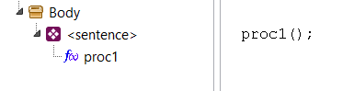
Converting this instruction to machine code is a simple task, since it will only be enough to generate the corresponding instruction: JSR <proc1 address>.

Let us now consider an assignment instruction:

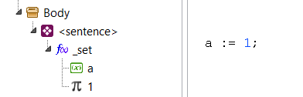

The AST now includes the _set() method with the corresponding parameters.

This way is easy to convert to machine code, since it only consists of calling the routine associated with the method _set() of the class of the operator "a", which if it is of type byte, then it will be: TGenCod. BOR_byte_asig_byte().

When the expression becomes complicated, then it becomes necessary to make adaptations of the AST, before the generation of code. Consider the following case:

FUNCTION CODING

The processing of the functions, up to the filling of the syntax tree, is described in the document "Documentation – Fundamentals and Analysis". This section will describe how code generation is performed for functions and the calling process.

While we know that Pascal differentiates procedures from functions, for documentation purposes, in this section we will use the term "function" to refer to both procedures and functions.

Types of functions

In the document "Documentation – Fundamentals and Analysis" the functions were described considering the classes that defined them (TEleFunBase, TEleFunDec and TEleFun) and the relationships between them.

This section will describe a categorization based on how functions are called.

For the best control of the calls and coding of the functions, a classification has been added to the functions, implemented in the following attributes of the TEleFunBase class:

TEleFunBase = class(TEleProgFrame)
...
public //References
callType: TCallType; //How to call the function.
//Routine BOR o UOR, when callType is ctSysInline.
codSysInline: TCodSysInline;
//Routine that generates code to function, when callType is ctSysNormal.
codSysNormal: TCodSysNormal;
...
end;

The types of function calls are those allowed by the "callType" property:

TCallType = (
ctUsrNormal, //Common user function
ctUsrInline, //Inline user function
ctSysNormal, //Common system function
ctSysInline, //Inline system function
ctUsrExtern //External function
);

The ctUsrNormal and ctUsrInline types correspond to the common functions that are defined within the source code of a program.

An example of a ctUsrNormal function would be:

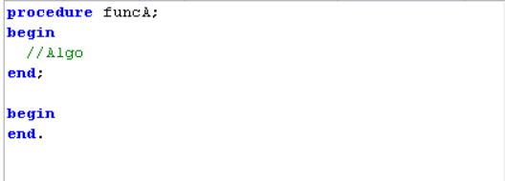

An example of a ctUsrInline function would be:

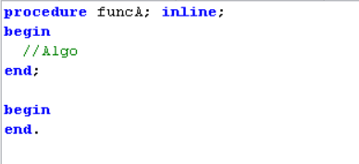

The reserved word INLINE indicates that the function will not be encoded as a normal function but that the function code will be inserted each time it is called.

These declarations, however, are not supported in the current version of the compiler.

The ctSysNormal and ctSysInline types are similar to their equivalents ctUsrNormal and ctUsrInline, with the difference that these functions are not created from the source code, but are created by the compiler itself before compiling any program.

These functions, created by the compiler, are located in the System drive and can be viewed from the code explorer:

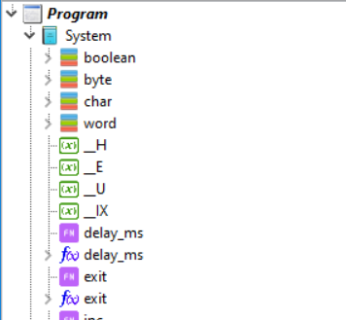

Normal user roles

Normal user functions are those that are created with the ctUsrNormal type and are the common functions that are defined in the source code. They may or may not have parameters.

These functions appear in the AST as code container elements that have a body:

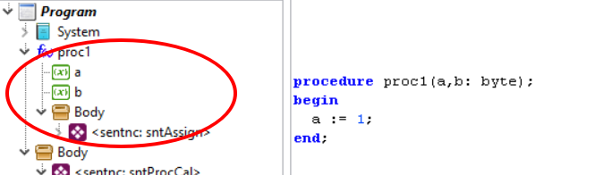

Code generation

ctUsrNormal functions are normal subroutines that are created in a specific direction in RAM.

Its code encoding is like a normal subroutine, which is called with a JSR statement and returned with an RTS statement:

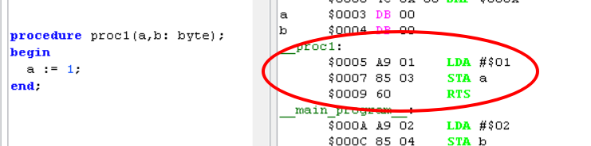

Only functions that have been identified as "used" are encoded in memory. This identification of "used" is made by the RemoveUnusedFunc() subroutine in the optimization phase, as described in section 10.5.

Code generation is done in TCompiler_PIC16. DoGenerateCode, previously identifying that it is a ctUsrNormal function:

procedure TCompiler_PIC16. DoGenerateCode;
...
begin
...
Encodes the subroutines used
for fun in usedFuncs do begin
if fun. IsInterrupt then continue;
case fun.callType of
ctUsrNormal: begin //Normal User Function
//Compile used function in the current address.
fun.adrr := pic.iRam; //Update the final address
GenCodeFunction(fun. BodyNode);
if HayError then exit; //Puede haber error
fun.coded := true; //Mark as already coded in memory.
...
end;
ctSysNormal: begin //Normal function of the system.
...
end;
end;
end;
...
end;

The code generation is done by GenCodeFunction() which is a subroutine that ends up calling GenCodeSentences() and includes the RTS return statement.

It must be considered that, in addition to the generation of code, there is a requirement to create the variables that will be used for the parameters.

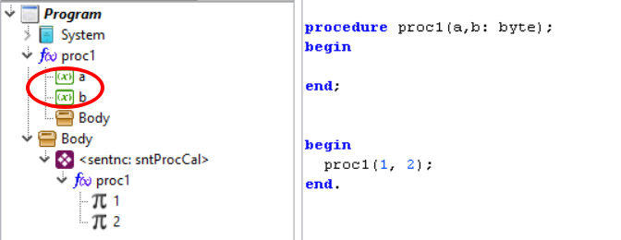

Parameter variables, in the AST, are created by the routine that analyzes the function declaration. These variables are created as local variables, in the same way that local variables of the function are created.

Function Call

Normal functions are stored as subroutines, in fixed memory positions, and must be called using the JSR statement.

JSR <subroutine address>

Like any expression, you must comply with returning the result in the work records.

As seen in the document "Documentation – Fundamentals and Analysis", after analysis, lexical, syntactic and semantic, normal functions appear in the syntax tree as follows:

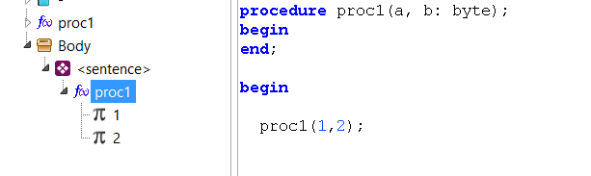
Which is a useful representation in the syntactic sense. But for the generation of code it is not very representative, because it does not directly reflect the operations that must be performed for the creation of the binary code.

To simplify code generation, you must separate this statement into two parts:

- The parameter filling part.
- The call to the subroutine.

To do this, the optimization routines perform the conversion in the same AST, so that this call takes the following form:

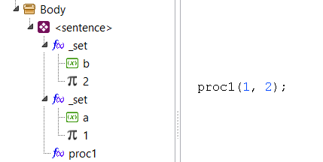

This transformation is carried out in the optimization phase and within TCompiler_PIC16. SplitExpressions(). For more information see section 10.6.

Note that the statement now contains three expressions, which are already easier to encode with binary operations routines, associated with the methods _set(), because the reading of parameters consists of assigning them to predefined global variables.

You might think that now you have the same problem because _set methods are also functions; but it must be remembered that these are INLINE methods and are encoded directly, without the need to use a JSR statement.

Reading parameters involves several assignment operations, but they are not part of the final expression that is the function call.

The call itself to the function is synthesized in TGenCodBas.GenCodeExpr(), calling functCall() which is responsible for generating the JSR statement:

procedure TGenCodBas.GenCodeExpr(eleExp: TEleExpress);
...
begin
if eleExp.opType = otFunct then begin
//It's an expression. There should be a function
funcBase := eleExp.rfun;
if funcBase.callType = ctSysInline then begin
//It's an INLINE function. It could be already implemented or not.
if funcBase.idClass = eleFunc then begin
//It's the implementation. No problem.
...
funcBase.codSysInline(eleExp); //Process function
//Check if we can simplify
...
end else begin
GenError('No support for unimplemented INLINE functions.' );
end;
end else if funcBase.callType in [ctSysNormal, ctUsrNormal] then begin
//Should be a Normal subroutine. Generates the CALL instruction.
functCall(funcBase, AddrUndef);
SetFunExpres(eleExp);
end else begin
GenError('Unsupported.' );
end;
end else if eleExp.opType = otConst then begin
...
end;
end;

Normal system functions

Normal system functions are those that are created with the ctSysNormal type. They are similar to normal user functions, but are not created in the source code but are created at the beginning by the compiler itself.

In addition, code generation is different because there is no source code of the system function.

All system functions are created in the System drive and can be viewed from the code explorer:

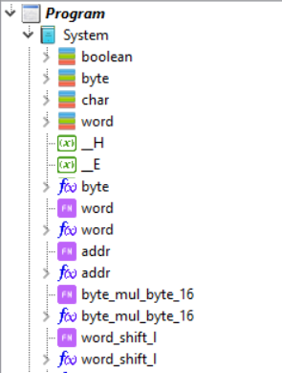

The function byte_mul_byte_16() is a normal function of the system that performs two-byte multiplication and returns a word. This function can be called directly from any program, but the compiler creates it to be used by the multiplication operator.

There are functions such as word() or byte(), also visible in the figure above, which are not normal system functions but are system INLINE functions (ctSysInline).

In the System unit, not only the ctSysNormal functions are created, but also the ctSysInline functions and some important variables, such as those used as work records.

CtSysNormal functions are not only created as separate functions (directly in System) but can also appear as methods of system types.

Code generation

ctSysNormal functions, like ctUsrNormal functions, are created as normal subroutines that are located in a specific direction in RAM.

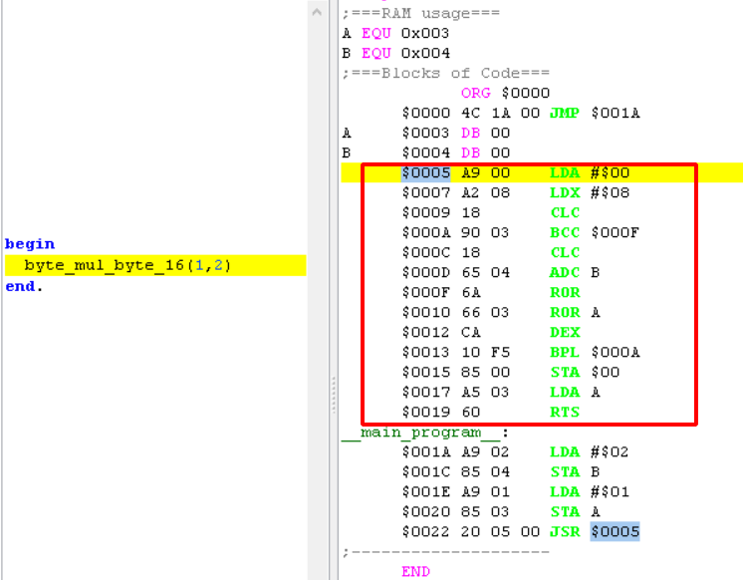

Only functions that have been identified as "used" are encoded in memory. This identification of "used" is made by the RemoveUnusedFunc() subroutine in the optimization phase, as described in section 10.5.

Code generation is done in TCompiler_PIC16. DoGenerateCode, previously identifying that it is a ctSysNormal function:

procedure TCompiler_PIC16. DoGenerateCode;
...
begin
...
Encodes the subroutines used
for fun in usedFuncs do begin
if fun. IsInterrupt then continue;
case fun.callType of
ctUsrNormal: begin //Normal User Function
//Compile used function in the current address.
fun.adrr := pic.iRam; //Update the final address
GenCodeFunction(fun. BodyNode);
if HayError then exit; //Puede haber error
fun.coded := true; //Mark as already coded in memory.
...
end;
ctSysNormal: begin //Normal function of the system.
//Compile used function in the current address.
fun.adrr := pic.iRam; //Update the final address
fun.codSysNormal(fun); //Routine for generating code
if HayError then exit; //Puede haber error
fun.coded := true; //Mark as already coded in memory.
end;
end;
end;
...
end;

Note that, unlike normal user functions, ctSysNormal functions have no code in their Body element:

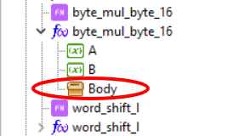

Therefore, you cannot generate code by compiling the instructions. Instead, a call is made to the "codSysNormal" property of TEleFunBase.

The codSysNormal property is a "callback" that is initialized at the time of creating the system function.

System functions are created in TGenCod.CreateSystemElements() which is where all system elements are created. Let's see, for example, the creation of byte_mul_byte_16():

procedure TGenCod.CreateSystemElements;
...
begin
...

//Multiply system function
setlength(pars, 0); //Reset parameters
AddParam(pars, 'A', srcPosNull, typByte, decNone); //Add parameter
AddParam(pars, 'B', srcPosNull, typByte, decNone); //Add parameter
f_byt_mul_byt_16 := AddSysNormalFunction('byte_mul_byte_16', typWord,
srcPosNull, pars, @byte_mul_byte_16);
...

end;

Normal system functions are created with AddSysNormalFunction() which assigns the "ctSysNormal" call type to the created function of type "TEleFun".

The parameters are created with AddParam() and stored in the "pars" array. This fix will then be moved to AddSysNormalFunction().

The final parameter is the address of the routine to be assigned to the "codSysNormal" of the "TEleFun" function to be created. In this case this routine is byte_mul_byte_16():

procedure TGenCod.byte_mul_byte_16(fun: TEleFunBase);
...
begin
fac1 := fun.pars[0].pvar;
fac2 := fun.pars[1].pvar;
requireH;
//A*256 + X = FAC1 * FAC2
_ldai($00);
_ldxi($08);
_clc;
_LABEL_pre(m0);
_BCC_post(m1);
_clc;
_adc(fac2.addr);
_LABEL_post(m1);
_RORa;
_ror(fac1.addr);
_dex;
_BPL_pre(m0);
//Returns in H,A
_STA(H.addr);
_LDA(fac1.addr);
_RTS();
end;

This is finally the function that creates the code of the "ctSysNormal" function.

Function Call

Normal system functions, like ctUsrNormal functions, are also called using the JSR statement.

JSR <subroutine address>

Like any expression, you must comply with returning the result in the work records.

These functions also go through the simplification stage in the AST. Starting with the parameters as TEleExpress elements:

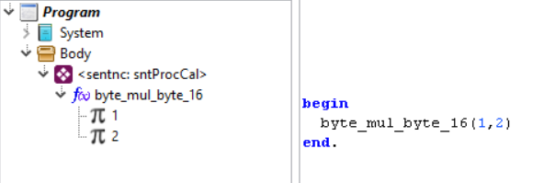

And then moving on to the form of pre-assignment of parameters with additional instructions and ending with the call to the function:

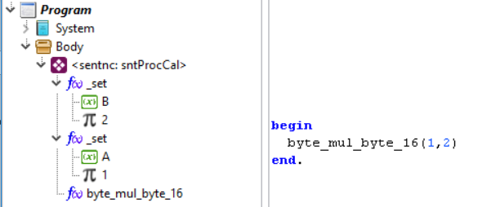

This transformation is carried out in the optimization phase and within TCompiler_PIC16. SplitExpressions(). For more information see section 10.6.

The call itself to the function is synthesized in TGenCodBas.GenCodeExpr(), calling functCall() which is responsible for generating the JSR statement:

procedure TGenCodBas.GenCodeExpr(eleExp: TEleExpress);
...
begin
if eleExp.opType = otFunct then begin
//It's an expression. There should be a function
funcBase := eleExp.rfun;
if funcBase.callType = ctSysInline then begin
//It's an INLINE function. It could be already implemented or not.
if funcBase.idClass = eleFunc then begin
//It's the implementation. No problem.
...
funcBase.codSysInline(eleExp); //Process function
//Check if we can simplify
...
end else begin
GenError('No support for unimplemented INLINE functions.' );
end;
end else if funcBase.callType in [ctSysNormal, ctUsrNormal] then begin
//Should be a Normal subroutine. Generates the CALL instruction.
functCall(funcBase, AddrUndef);
SetFunExpres(eleExp);
end else begin
GenError('Unsupported.' );
end;
end else if eleExp.opType = otConst then begin
...
end;
end;

INLINE System Functions

The INLINE functions of the system are those that are created with the ctSysInline type. They are created at the beginning by the compiler itself.

All system functions are created in the System drive and can be viewed from the code explorer:

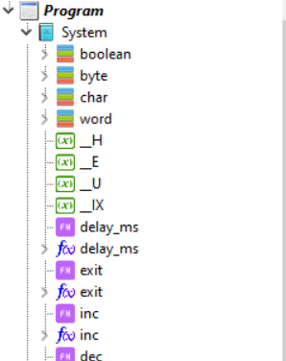

Functions such as inc() or dec() are INLINE functions of the system, like most functions created in the System unit.

Code generation

The ctSysInline functions, being a system function, are cea when starting the compiler in the System drive.

The INLINE functions of the system have a Body element but do not have code in it:

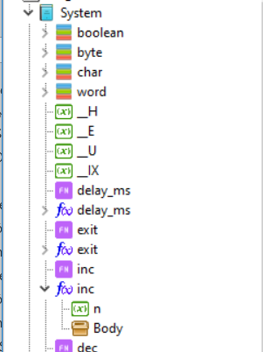

The Body element is created to keep uniformity in the functions and also to be able to include references ("callers") to other elements of the AST.

Note that system functions can also be created in two parts (declaration and implementation), as shown in the figure above.

The code that is generated, when calling the function, is not created as a subroutine in RAM but is generated dynamically when calling the function. Consider for example the case of the function inc():

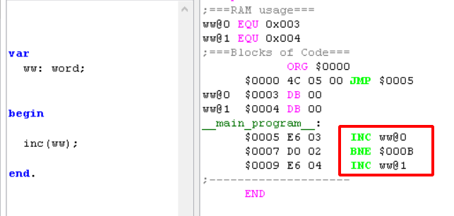

The generated code is displayed highlighted on the right. This code is created in a custom way for the parameter "ww".

The inc() function is created in TGenCod.CreateSystemElements() as all system functions:

procedure TGenCod.CreateSystemElements;
...
begin
...

//Create system function "inc"
setlength(pars, 0); //Reset parameters
AddParam(pars, 'n', srcPosNull, typNull, decNone); //Parameter NULL, allows any type.
AddSysInlineFunction('inc', typNull, srcPosNull, pars, @fun_Inc);

...

Note that the creation of this function is similar to the creation of normal system functions.

The first part of the creation corresponds to the creation of the function parameter. Note that a particular type is not specified for the parameter. This is a prerogative of the INLINE functions of the system. ctSysInline functions can work with untyped parameters (and from any storage). It will correspond to the code of the function to validate if the parameter is valid.

Unlike normal functions, the INLINE functions of the system can return any type of storage. The type of data they return (when they return something) does have to be specified at the time of creation with AddSysInlineFunction().

The routine that will finally generate the code for the INLINE function is also specified in AddSysInlineFunction(), in the final parameter, which in our case is fun_Inc(). This is the "callback" that will be recorded in "codSysInline" of the created TEleFun object.

The simplified code of fun_Inc() is:

procedure TGenCod.fun_Inc(fun: TEleExpress);
...
begin
par := TEleExpress(fun.elements[0]); //Only one parameter
//Validations for variable
...
//Code generation
case par. Sto of
stConst: begin
GenError('Cannot increase a constant.' ); exit;
end;
stRamFix: begin //A common variable
if (par. Typ = typByte) or (par. Typ = typChar) then begin
_INC(par.rvar.addr);
end else if par. Typ = typWord then begin
_INC(par.rVar.addr);
_BNE_post(LABEL1); //label
_INC(par.rVar.addr+1);
_LABEL_post(LABEL1);
end else if par. Typ.catType = tctPointer then begin
It is short pointer
_INC(par.rVar.addr);
end else begin
GenError(MSG_INVAL_PARTYP, [para. Typ. name]);
exit;
end;
end;
stRegister: begin
...
end;
stRegistA: begin
_CLC;
_ADCi(1);
end;
stRegistX: begin _INX; end;
stRegistY: begin _INY; end;
else
genError('Not implemented "%s()" for operands "%s".' ,
[fun. name, para. StoAsStr], para. srcDec);
end;
end;

We can observe that the generation of the code of this function, which should only increase the parameter, is done by first identifying the storage and the type of data.

Initial validation is only to make sure that it is about incrementing a variable and not a constant or expression.

Most INLINE functions created by the system work in this way.

Now, the implementation of the "codSysInline" function also does not have to be done in fun_Inc(), as is the case here. The deployment can include only one call to a subroutine that will be the one that will do the implementation of the function. This is the case of the system function _mul()," which is created as a method of type Byte.

Of course, if you are only going to implement an INLINE function to call a subroutine in RAM, it would not make sense to define it as ctSysInline and it would be enough to create it as ctSysNormal, or as ctUsrNormal and include it in a unit.

The system INLINE function Byte._mul() does some pre-validations to see if it can implement multiplication without having to call the routine byte_mul_byte_16().

The advantage of creating INLINE functions is that you can optimize the generated code quite well and that you are not restricted to a fixed type of data storage.

Function Call

INLINE functions are not "called" in the sense of normal functions. What is done is to call the "codSysInline" function of the TEleFunBase element when necessary.

By calling "codSysInline", you are calling the BOR or UOR routine (or a similar one) that will generate the code of the INLINE function.

To do this, the INLINE function called in the source code is first identified in the analysis process. This task is performed in TCompilerBase.GetExpression() and, more specifically, in the routines TCompilerBase.GetOperand(), MethodFromBinOperator() and MethodFromUnaOperator(), depending on whether it is identified as an operator or as a method:

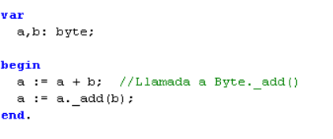
Both ways of calling the _add() method are equivalent.

Remember that almost all the operators that are defined in the System Unit, are encoded as INLINE functions.

In conclusion, the call to the INLINE function, which involves the generation of code is done from TCompilerBase.GetExpression(), in the synthesis process carried out by TCompiler_PIC16. DoGenerateCode().

Feature Summary

The following table summarizes the types of functions exposed:

NORMAL FUNCTIONS |  | INLINE FUNCTIONS
USER | OF THE SYSTEM | USER | OF THE SYSTEM
They are created by the user in the program to be compiled. | They are created by the same compiler at startup. | They are created by the user in the program to be compiled. | They are created by the same compiler at startup.
The call first involves assigning the parameters to global variables. |  |  | The call can directly use the parameters without using variables.
The function exists as a subroutine and is called with a JSR. |  | The function code is created when a call is implemented and does not include a call to a specific subroutine.

Generation of the code for the body of functions.

Except for the initialization routine, the entire synthesis task in the compiler consists of generating code for two types of functions:

- User or system functions.
- The main body of the program, considered as one more function.

This code generation work can be seen in TCompiler_PIC16. DoGenerateCode() where code is synthesized both for the functions, as well as for the main body of the program, since both are conceptually similar (both are program frameworks that descend from the TEleProgFrame class).

The differences of the main body of the program with respect to the body of functions, are:

- A JSR statement, or one called INLINE, will not be generated.
- It will always be used and coded. Functions may not be used and may not become code.
- Exit() statements are processed differently.
- They do not necessarily include an output instruction, as they could be infinite loops. Functions always include an RTS or RTI as an output instruction.
- They do not receive parameters and do not return output values.
- They are encoded at the end of the code.

Otherwise, it can be said that the code generation process is similar in both cases.

The functions can also be of type INTERRUPT and in this case they are encoded differently. There are also certain optimizations that apply when generating the RTS/RTI output instruction and that will be seen in Section 8.4.

Whether it is functions or the main body of the program, the encoding is done sentence by sentence, as can be seen in TGenCodBas.GenCodeSentences().

Function Call

A function is one more operand, which will usually return an expression (TEleExpress. opType = otFunct), of a certain type, which could be typNull for the case of procedures.

Also expressions with operators, such as: (1+x), will appear in the Syntax Tree, as simple function calls (See document "Documentation – Fundamentals and Analysis"), so the coding described here is also applicable to this type of expressions.

How a call will be encoded will depend on whether the function is a Normal or INLINE Function.

Parameter Optimization for Normal Functions

In the normal way of working, the parameters of the procedures are handled as global variables, independent for each procedure, which are only accessible from within the procedure, so that for the programmer they behave as if they were, really, local variables.

And that way of working works well, but there is the problem that when the number of procedures grows, so does the number of variables in RAM, which are used for parameter handling.

The memory optimization used for parameters is based on the fact that:

"In a common Pascal program, with various procedures declared and used, there may be parameters that will never be used simultaneously."

To clarify this statement let's consider the following code:

procedure proc1(a1:byte);
begin
end;

procedure proc2(a1:byte);
begin
end;

begin
%1(1);
%2(2);
end;

This is a simple case of a program calling two procedures, which are at the same nesting level, seen from the main program.

A diargama of calls, would be this:
proc1(a1: byte)
proc2(a2: byte)
main()

Here main() represents the main program.

As within proc1(), proc2() will never be accessed and vice versa, it can then be said that the parameters of proc2() are independent of the parameters of proc1().

This is a case in which global variables, which are used for parameters, can be reused.

If we compile this program in a normal way, the assembly code would be:

;===RAM usage===
a1 EQU 0x00C
a2 EQU 0x00D
;------ Work and Aux. Registers ------
;===Blocks of Code===
0x000 goto 0x003
__proc1:
;end;
0x001 RTS
__proc2:
;end;
0x002 RTS
__main_program__:
;proc1(1);
0x003 movlw 0x01
0x004 movwf a1
0x005 call 0x001
;proc2(1);
0x006 movlw 0x01
0x007 movwf a2
0x008 call 0x002
__end_program__:
;end.
0x009 sleep
;--------------------
END

Where you see that a variable is being used for each parameter. However, it is possible to reuse that variable as they are independent, so that a single RAM position is used. The assembly code would then be:

;===RAM usage===
a1 EQU 0x00C
a2 EQU 0x00C
;------ Work and Aux. Registers ------
;===Blocks of Code===
0x000 goto 0x003
__proc1:
;end;
0x001 RTS
__proc2:
;end;
0x002 RTS
__main_program__:
;proc1(1);
0x003 movlw 0x01
0x004 movwf a2
0x005 call 0x001
;proc2(1);
0x006 movlw 0x01
0x007 movwf a2
0x008 call 0x002
__end_program__:
;end.
0x009 sleep
;--------------------
END

Not in all cases, the memory used in the parameters can be reused.

Let's consider the following program:

procedure proc1(a1: byte): byte;
begin
end;

procedure proc2(a2: byte): byte;
begin
proc1(1);
end;

begin
proc2(1);
end.

Here proc2() calls proc1(), therefore, it is not feasible to reuse the parameter, since while running proc2(), it should not be altered at all "a2".

A more general algorithm could be established to determine the cases in which the memory used for the parameters can be reused or not.

Let's consider the following call tree.

proc1(a1: byte)
proc3(a1: byte)
main()

proc2(a2: byte)

As we have deduced, nested procedures do not have independent parameters, so they cannot be reused.

So a simple method, to detect procedures that can share their parameters, is to take those that are terminals in the procedure call tree.

In our example, we tend that the procedures that can share their parameters are proc3() and proc2().

An important detail is that both the parameters of the procedures, as well as their local variables, are all considered as local variables and are susceptible to be reused.

But consider the following variation, in which proc4, does not use local variables:

proc1(a1: byte)
proc3(a1: byte)
main()

proc4
proc2(a2: byte)

If we applied the simple method of the terminals we would identify proc3 and proc4, to share memory, but we see that it would be useless, because proc4, does not use parameters or local variables.

Therefore, an improvement to the algorithm is to identify as terminals only those procedures that use local variables / parameters and that all the functions that call directly or indirectly, do not have local variables / parameters.

Applying this variation, we would identify proc2 and proc3:

proc1(a1: byte)
proc3(a1: byte)
main()

proc4
proc2(a2: byte)

The implementation of this method of reuse of variables is implemented in P65Pas, in the TGenCodBas method. CreateLocalVarsAndPars:

procedure TGenCodBas.CreateVarsAndPars;
{Create in RAM, local variables and parameters for functions.}
...
begin
Explore terminal functions first
for fun in usedFuncs do begin
if not fun. IsTerminal2 then continue;
Local parameters and variables appear as elements of the function
for elem in fun.elements do if elem.idClass = eleVarDec then begin //Para todas sus variables.
xvar := TEleVarDec(item);
if xvar. IsParameter or //If function is used, we assume the all the parameters too.
(xvar.nCalled>0) then begin
//Asign RAM space to this variable in shared mode.
CreateVarInRAM(xvar, true);
if HayError then exit;
end;
end;
if OptReuProVar then SetSharedUnused; //cleans used positions
end;
if OptReuProVar then SetSharedUsed; //Now mark as used, because the shared byte zone has already been created
Explore only non-terminal functions
for fun in usedFuncs do begin
if fun. IsTerminal2 then continue;
Local parameters and variables appear as elements of the function
for elem in fun.elements do if elem.idClass = eleVarDec then begin //Para todas sus variables.
xvar := TEleVarDec(item);
if xvar. IsParameter or //If function is used, we assume the all the parameters too.
xvar.required or //Variable is used as a register and it's used.
(xvar.nCalled>0) then begin
//Asign RAM space to this variable in Normal mode.
CreateVarInRAM(xvar, false);
if HayError then exit;
end;
end;
end;
Reserve space for variables (Non-function variables)..
for xvar in TreeElems.AllVars do begin
if xvar. Parent.idClass = eleFunc then continue; //Function variables have already been created
if (xvar.nCalled>0) or xvar.required then begin
Assign a valid address for this variable
CreateVarInRAM(xvar, false);
if HayError then exit;
end else begin
Unused variable
xvar. ResetAddress;
if xvar. Parent = TreeElems.main then begin
Generates message only for main program variables.
GenWarn(WA_UNUSED_VAR_, [xVar. name], xvar.srcDec);
end;
end;
end;
end;

In summary, what this procedure does, is to first create in RAM, the variables for the terminal functions, in "shared" mode, using AssignRAMtoVar(). The variables are then created in normal mode (separate positions) using Also AssignRAMtoVar().

To reuse the local variables of the procedures, you must first update the list of procedures called by each procedure. This is done with UpdateFunLstCalled(), and its work can be verified by viewing the listing report, from the "Tools" menu:

------------------------------------
----- PROCEDURE proc2
------------------------------------
Caller Procedures:
- Main

Called Procedures:
- proc1

Exit Instruction Calls:
<none>

Terminal procedures are determined using the fun method. IsTerminal2, which finally implements the terminal function identification algorithm.

Optimizing the RTS instruction

Every procedure or function must have at least one RTS statement, upon completion.

The simplest case to compile would be, something like this:

procedure simple(a: byte);
begin
a := 1;
end;

This simplistic procedure would be compiled with the following code:

__simple:
$0004 A9 01 LDA #$01
$0006 85 03 STA to
$0008 20 RTS

Including the RTS instruction, at the end of the subroutine.

Compiling this case is simple because, it would only be enough to always encode the RTS statement at the end of a procedure.

But when the exit() statement is compiled, the value to be returned should be loaded into the WRs and generate a call to RTS.

Let's consider something like:

procedure simple: byte;
begin
exit(1);
end;

And if the same method is applied, you would have:

__simple:
0x004 movlw 0x01
0x005 RTS
0x006 RTS

But this coding is not at all efficient, for two details:

- DETAIL 1: A load to W instruction is being used, and then an RTS, when a simple RETLW could be used.
- DETAIL 2: An additional and unnecessary RTS is being included at the end of the procedure.

To work around these details, optimization techniques are used in compiling the procedures:

DETAIL 1 is solved in a simple way, using an additional parameter in the TEleTypeDec event. OnLoadToRT(), to tell the code generator that not only should the operand be loaded into the WRs, but also that you want to generate an RTS statement.

The OnLoadToRT() routine can then optimize the RTS, using RETLW, when it can be used. As an example we can examine the routine TGenCodBas_PIC16.byte_LoadToRT():

procedure TGenCodBas_PIC16.byte_LoadToRT(const OpPtr: pointer; modReturn: boolean);
{Load operating to work logs.}
where
On: ^TEleExpress;
varPtr: TEleVarDec;
begin
On := OpPtr;
case Op^. Sto of
stConst : begin
if modReturn then _RETLW(Op^.valInt)
else _MOVLW(Op^.valInt);
end;
...
end;

DETAIL 2 is more difficult to optimize and required the creation of so-called "syntax blocks" (See Section 2.3).

In short, what is done is to determine if there is an appropriate exit() statement, so as not to have to include the final RTS, in the compiled code.

An "appropriate" exit() statement is defined as an instruction that is at the end of a procedure and is not within a conditional structure.

A good example would be:

procedure simple: byte;
begin
a := 1;
exit(1);
end;

And a bad example would be:

procedure simple: byte;
begin
if a>0 then
exit(1);
end;
end;

To detect these cases, it is that syntax blocks are used. In summary, the following theorem is used:
EXIT THEOREM
"If in a procedure there is at least one exit(), in mandatory code, it is not required to encode an RTS at the end of the procedure"

You might think that this would fail if instructions are included after an exit(), as in the case:

procedure simple: byte;
begin
exit(1);
a := 1;
end;

But it can be clearly seen that the theorem is still being fulfilled, with the observation that this procedure has unreachable code (which is never executed), and therefore no additional RTS is required to be encoded. In fact, it is not even required to encode the code after the exit().

This can be deduced from the COROLLARY of section 3.2.1.

OPERATING ROUTINES

The main section, in code generation, is the so-called operation routines (RO).

It is known as Operation Routines to the code used, mainly, to generate code for the operators of the language.

These operators are defined as methods of internal types such as Byte, Word, or Boolean:

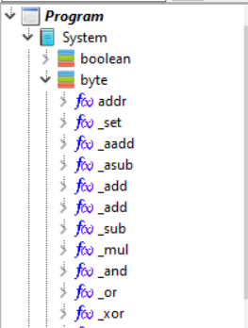

These methods are implemented as INLINE functions that are defined internally. Each method represents an operation (arithmetic, logical or otherwise) and is defined for an operator and a type (See document "Documentation – Fundamentals and Analysis.docm").

One of these operations is, for example, the one that processes this expression:

a + b

The RO for this expression (which we will also call "underexpression") could be TGenCod.BOR_byte_add_byte().

RO is implemented in the GenCod_PIC16 unit.

In summary, an Operation Routine is:
The program that is called when you want to synthesize an operator (generate code) that meets the following conditions:
- They are operators defined as methods of the system types (Declared in the System unit).
- They are operators implemented as INLINE functions.

Types of Operation Routines

Operation routines are classified according to the type of operand they implement:

- Binary Operation Routines (BOR) -> Implement the code of binary operators such as "a+b" or "a>>2".
- Unary Operation Routines (UOR) -> Implement the code of unary operators as "@a".

If there were ternary operators, we would have to talk about a new type of Operation Routines, but in that case, there would not be much difference in implementation.

The name of the Operation routines allows to identify the type to which they belong, so the BOR have names such as "BOR_byte_add_byte" and the UOR have names such as "UOR_not_byte".

Subexpresiones

Subexpressions are defined as simple expressions that include a single operator and one or two operands such as:

a + b //Binary underexpression. Equivalent to "a._add(b)".
not x //Subexpresión unaria.

Subexpressions also work similarly to expressions in that they usually return their results in work records (they are stFunct elements), and can use auxiliary records.

The treatment of expressions is recursive, so that any expression, however complex, will always be reduced to a finite set of binary and unary Subexpressions.

This is the foundation on which the code generator in P65Pas is built (and it is the way Xpres works).

Remember that according to the XPres framework simple expressions such as "5" or "variable1", (stConst or stRamFix operands) do not generate evaluation code.

Subexpressions are synthesized (code generation stage) with the Operation Routines.

Representation in the AST

Operation Routines are represented, within the AST, as elements of the syntax of the TEleExpress type, because they also behave as expressions.

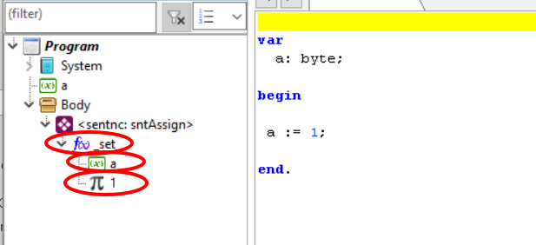

The child nodes of a TEleExpress are also TEleExpress elements.

Now, depending on the type of operand of TEleExpress, they are represented within the AST with different icons:

TEleExpress of type otConst.

TEleExpress of type otVariab.

TEleExpress of type otFunct.

It should be noted that while an Operation Routine may initially appear as otFunct, it is possible that optimization routines will later change their type to become otConst or even otVariab. Such is the case of expressions with constants:

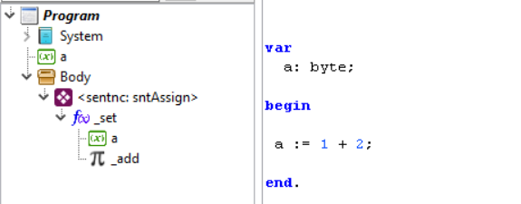

Here the "_add" operation has become a constant after previously folding "1 + 2" because this is how it is convenient to handle it.

Calls to operation routines

Binary operations call the trading routines, defined in the unit GenCod_PIC16, according to the following rules:

- Operands are the parameters of the expression "fun" (fun.elements[i]) that reaches the BOR.
- The storage of each operand, can be read in the attribute ". Sto."
- The combined storages of the two operands can be read with the function "stoOperation()".
- The result must be returned in the same expression "fun". The fields that should always be filled in are "Sto" and "typ".
- The additional fields, to be updated in "fun", will depend on the storage and type you return.

As an example, let's consider the operation routine BOR_word_add_word():

procedure TGenCod. BOR_word_add_word(fun: TEleExpress);
begin
...
parA := TEleExpress(fun.elements[0]); //Parameter A
parB := TEleExpress(fun.elements[1]); //Parameter B
case stoOperation(parA, parB) of
stConst_Variab: begin
SetFunExpres(fun);
requireH;
_CLC;
_LDAi(parA.valL);
_ADC(parB.addL);
_TAX; //Save
_LDAi(parA.valH);
_ADC(parB.addH);
_STA(H.addr);
_TXA; //Restore A
LastIsTXA := true;
end;
...

Having the stoOperation function, avoids us having to make a double comparison with the storages of the two operands.

Note that when the parA operand is of constant type, we read its value using the property parA.valL and parA.valH, which are properties that apply to constants.

On the other hand, when parB is of variable type, we use the properties parB.addL and parB.addH, to access the physical addresses of the variable.

The type and storage of the result (among other validations), are defined with SetFunExpres(). This is mandatory, so that the compiler can continue working.

In addition to "typ" and "Sto", other additional fields must be fixed according to the following table:

Value of "Sto" | Additional fields to fill, of "fun".
stConst | It must be updated:  valInt, si "typ" es Char, Byte o Word.  valFloat, if "typ" is Float. (not yet implemented)  valBool, si "typ" es Boolean.
stRamFix | Only "rvar" should be updated.
stRegister | No need to update any more fields

To facilitate the updating of "fun", in BOR routines, and also in UOR, various methods have been created:

procedure SetFunNull(fun: TEleExpress);
procedure SetFunConst(fun: TEleExpress);
procedure SetFunVariab(fun: TEleExpress; rVar: TEleVarDec);
procedure SetFunVariab(fun: TEleExpress; addr: word);
procedure SetFunVariab_RamVarOf(fun: TEleExpress; rVar: TEleVarDec;
offset: integer);
procedure SetFunExpres(fun: TEleExpress);
procedure SetFunConst_bool(fun: TEleExpress; valBool: Boolean);
procedure SetFunConst_byte(fun: TEleExpress; valByte: integer);
procedure SetFunConst_char(fun: TEleExpress; valByte: integer);
procedure SetFunConst_word(fun: TEleExpress; valWord: integer);

They contain the necessary parameters and, in addition, configure some important expression variables (See section 11.4)..

Due to the way they are defined, these routines can also be used from outside ROP, but taking into account the possible consequences, such as generating error or generating unnecessary or erroneous code.

Implementation of Operation routines

Operation routines are those that generate the code for a specific operation, such as: "byte + word", "word>word" or "-byte"

In theory, binary operation routines should be implemented for all storage combinations:

- stConst with stConst
- stConst with stRamFix
- stConst with stRamVarOf
- stConst with stRamReg
- stConst with stRegister
- stConst with stRegistA
- stConst with stRegistX
- stConst with stRegistY
- stRamFix with stConst
- ...

Which correspond to the combinations of the storages of the operands.

Not all cases are valid for all operations, for example, for assignments, only the first operand will be allowed to be a variable, so the types of storage allowed are restricted.

In the same way, unary operations should implement all storage cases :

- stConst
- stRamFix
- stRamVarOf
- stRamReg
- stRegister
- stRegistA
- stRegistX
- stRegistY

They correspond to all types of possible storages of operands, but in practice not all are used or worth implementing.

All binary operations are associated with a function or method and it is from this function that the two parameters are obtained. Seen from the AST, they would be the child nodes.

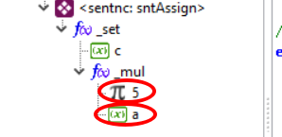

The functions of a BOR or UOR would be:

- Set the type and storage of the function associated with the BOR or UOR.
- Process the special modes of the compiler.
- Update global variables such as (lastASMcode, lastASMaddr , or AcumStatInZ).
- Generate the code for each of the operand combinations.
- Detect and process possible errors found.

As an example, a simplified version of the operation routine can be taken BOR_byte_equal_byte:

procedure TGenCod.BOR_byte_equal_byte(fun: TEleExpress);
where
parA, parB: TEleExpress;
begin
parA := TEleExpress(fun.elements[0]); //Parameter A
parB := TEleExpress(fun.elements[1]); //Parameter B
//Process special modes of the compiler.
if compMod = cmConsEval then begin
//Cases when result is constant
if (parA.Sto = stConst) and (parB.Sto = stConst) then begin
SetFunConst_bool(fun, parA.val = parB.val);
end;
exit;
end;
//Code generation
if parA.Sto = stConst then begin
case parB.Sto of
stConst: begin //Ccompar constants. Special case.
SetFunConst_bool(fun, parA.val = parB.val);
end;
stRamFix: begin
SetFunExpres(fun);
_LDA(parB.add);
_CMPi(parA.val);
Copy_Z_to_A;
end;

...

end else if parA.Sto = stRamFix then begin

...

end else if parA.Sto in [stRegister, stRegistA] then begin

...

end else begin
genError(MSG_CANNOT_COMPL, [BinOperationStr(fun)], fun.srcDec);
end;
end;

The first part of bor is the extraction of parameters as TEleExpress elements.

Then you have the code that processes the special modes of calling this BOR, these modes are: cmConsEval (special mode) and cmGenCode (default mode).

Here, you can see the implementation of the various cases of this binary operation, which are generated with a CASE statement for each cado of an IF conditional.

The first observation is in the way in which the operation "st Const_Const" is implemented. The result is returned as another constant, without the need to generate code.

By optimization, it will always be about returning the simplest storage in an operation. The preferred one is stConst, comes the stRamFix and then the others.

Review of Operating Routines

Any new operation routine, which is implemented, must be accompanied by your test code (Test Pattern), from the ROP. Take the byte equality operation test code as an example:

//stConst_Const
if 0 = 0 then good else bad end;
if 0 = 1 then bad else good end;
if 255 = 255 then good else bad end;
if 0 <> 0 then bad else good end;
if 255 <> 0 then good else bad end;

//stConst_Variab
a := 10;
if 10 = a then good else bad end;
if 0 = a then bad else good end;
if 10 <> a then bad else good end;
a := 255;
if 255 = a then good else bad end;

//stVariab_Const
a := 10;
if a = 10 then good else bad end;
if a = 0 then bad else good end;
if a <> 10 then bad else good end;
if a = 5+5 then good else bad end;

//stVariab_Variab
...

A testing pattern should be as detailed as possible, to detect potential deployment issues.

A simulator such as CCS64 is usually used to verify that the results are correct.

After the operation has been implemented and the test pattern verified, the generated code should be analyzed for unnecessary operations or additional memory used.

There is no formal method to review unnecessary operations, you would only expect the sequence of operations to be done as defined in this documentation.

Nor, there is a method to detect additional memory used, but it should first be verified that:

- If the generated code uses auxiliary variables, the use of these auxiliary variables must be justified. Usually the use of auxiliary variables depends on the implemented algorithm, but its use should be restricted.
- If the generated code uses the stack (Page 1), the use of this stack must be justified. The stack is used to simplify operations, in size and speed.

OPTIMISATION

The optimization process consists of processing and simplifying the AST, after it has been filled in the Analysis, in order to leave it ready for an optimal generation of the binary code (Synthesis).
AST after Analysis
Optimization
Optimized AST

Within P65Pas, the overall objectives of the optimizer are:

- Delete unused items, such as procedures and variables.
- Folding and propagation of constants.
- Reusability of variables used as function parameters.
- Locate the functions with the best order, with respect to the main program, to achieve the desired optimizations.

Points 1 and 3 are especially important to save memory, especially in this type of device. Point 1, is indispensable, for the management of libraries in P65Pas, otherwise even the simplest program that uses units, would overflow in memory easily.

The scope of work of the optimizer is only the AST. However, for this task, additional structures are used to assist in the manipulation of the AST.

Optimization routines are mainly declared in the Compiler_PIC16 unit and the procedure that calls all these routines is TCompiler_PIC16. DoOptimize().

AST status.

The AST, which you have to start the optimization process, is the one you have after the analysis process (See section "SYNTAX TREE" of the document "Documentation – Fundamentals and Analysis").

This AST, already built, has all its nodes already identified (It is known who are TEleExpress or TEleVarDec or TEleUnito ...) and resolved (Named operands point to their statements). In addition, it has the following characteristics:

- The nodes of the AST, of type expression (TEleExpress):
  - They already have their data type defined.
  - They do not have the storage defined, except for some cases of constants.
- Some TEleConstDec (or TEleExpress nodes of type otConst) might not be evaluated in value.
- TEleVarDec nodes do not yet have an address in RAM.

this state is summarized in the following table

PHASE | TEleExpress Nodes | TEleConsDec Nodes  about TEleExpress-coConst | TEleVarDec Nodes
After the analysis. | Type defined.  Not complete storage. | Some are not evaluated. | They do not have a RAM address assigned.

It should be noted that in this state no code generation has yet been carried out and that there is no complete requirement of variables or functions that will be used.

Build modes

To successfully execute the optimization process, a state variable has been defined to allow you to explore the AST in different working modes.

This variable is TGenCodBas.compMod of type TCompMod:

TCompMod = (
cmGenCode, //Generating code
cmConsEval //Evaluating constant
);

Optimization Processes

While optimization, as such, should focus only on improving AST so that synthesis produces optimal code in space and speed; the truth is that the optimization of P65Pas performs additional tasks in the AST, which are not typical of optimization, but are necessary for code generation to be carried out.

One of these tasks is, for example, the evaluation of constants, which is necessary to obtain the final value of other constants. See section 5.2.

Currently, the processes included in optimization are:

- Detection of unused items
- Identification of calls between elements.
- Evaluation of declared constants.
- Simplification of expressions.
- Constant bending.

This same order is executed in the optimization, as can be seen in the DoOptimize() function:

procedure TCompiler_PIC16. DoOptimize;
...
begin
...
//Detecting unused elements
RefreshAllElementLists;
RemoveUnusedFunc;
RemoveUnusedVars;
RemoveUnusedCons;
RemoveUnusedTypes;
//Updating callers and calleds.
UpdateFunLstCalled;
if HayError then exit;
SeparateUsedFunctions;
//Evaluate declared constants
EvaluateConstantDeclare;
if HayError then exit;
//Simplify expressions
bod := TreeElems.BodyNode; //read Main Body Node
SplitExpressions;
//Constant folding
ConstantFolding;
if HayError then exit;
end;

Each of these processes is described in detail below.

Detection of unused items

The first optimization, and perhaps the main function, that is performed in the linking, is to determine the syntactic elements that are not used in the program, to avoid compiling them by spending memory unnecessarily.

The use or not, of the elements, is determined by the value of its nCalled field (See information about the Syntax Tree in the document "Technical Documentation – Fundamentals"), which indicates the times that the element is called by some other element of the source code.

The detection of unused elements is based on updating the calls that are made to the elements, so that if there are no calls to that element (nCalled = 0) it is assumed that the element is not used.

Among the elements that should be reviewed are:

- The constants.
- The variables.
- Functions (procedures).
- The units
- Types

While constants and types do not take up memory space, they are analyzed to determine unit usage. And the use of units should be checked to determine if their INITIALIZATION and FINALIZATION sections are called.

Analysis to determine unused elements within a program is not a simple job. It requires clear language management and involves recursive searches and iterative processes.

The starting point is syntax tree, but beyond that, there doesn't seem to be a single or more efficient technique.

The analysis is complicated by the fact that the various elements to be used are related. Some of these dependencies are:

- Unused constants can make other unused constants, or unused units.
- Unused variables can influence other unused variables and even constants.
- Unused functions influence variables, constants, types, or even other unused functions.
- Unused units can determine unused variables, constants, types, or functions.

These dependencies, which are related to the definition of language, complicate the picture at the time of analysis.

A table better shows the identified dependency relationships:

Can influence | Constants in the used | Unused variables | Unused features | Types in used | Units in used
Constants in the used | When there is constant-constant dependence:  CONST  CONS1=CONS2+1; |  |  | If they are constants of that kind. | When they are declared in the unit.
Unused variables | When there is variable-constant dependency:  WHERE  v1: byte absolute CONST1; | When there is variable-variable dependency:  WHERE  v1: byte absolute v2; |  | If they are variables of that type. | When they are declared in the unit.
Unused functions | When they include local constants. | When they include local variables. | When they include local functions. | When they include definitions of local types or include variables/constants of that type. | When they are declared in the unit.
Types in used |  |  |  |  | When they are declared in the unit.
Units in used | When they include constants. | When they include variables. | When they include features | When they include types. | When using other units:  USES …

The case of units is special, because the use of the units themselves does not depend on whether they are declared in the USES statement, but on whether or not the elements of the units are used. And that, in turn, determinates whether or not the INITIALIZATION and FINALIZATION sections are executed.

From the analysis of these dependencies, a strategy can be proposed to solve the problem of detection of unused elements.

Elements of type "function" are less influenced by other elements, so they will be a good point of analysis to start discarding the other unused elements.

Therefore, the starting point of the analysis is to determine the unused functions, and then eliminate the local elements it contains and the calls to gloable elements (which can be to other functions), and thus continue advancing in the analysis.

Unused functions

The first optimization is to determine the functions that are not used, to avoid compiling them by spending memory unnecessarily.

The logic for determining unused functions is simple (at least the first approximation). It verifies the times a function is called, if it is zero, it means that it is not used. This simple verification is possible, because all the syntactic elements keep a record of the calls that are made to them, saving important information about these calls (See txpElement.lstCallers list).

Code that implements this logic can be viewed in the TCompilerBase.RemoveUnusedFunc() function, in the local RemoveUnusedFuncReferences() function:

function RemoveUnusedFuncReferences: integer;
...
begin
Result := 0;
for fun in TreeElems.AllFuncs do begin
if fun.nCalled = 0 then begin
inc(Result); //Keep track
If the function is not used, neither are its local elements
fun. SetElementsUnused;
calls you make to other functions are also removed
for fun2 in TreeElems.AllFuncs do begin
fun2. RemoveCallsFrom(fun. BodyNode);
end;
Including system functions
for fun2 in listFunSys do begin
fun2. RemoveCallsFrom(fun. BodyNode);
end;
end;
end;
end;

An unused function also implies that its variables or local constants will not be used either, therefore, all its elements are marked as unused, calling fun. SerElementsUnused().

Then it should also be considered that, if a function is not being used, the calls it makes to other functions must also be withdrawn, to be consistent.

However, making a call to RemoveUnusedFuncReferences(), does not guarantee that all unused functions will be removed, since deleting references may have generated new unused functions, which have not been detected in this pass.

Therefore, several passes are made to RemoveUnusedFuncReferences(), until the number of unused functions is detected is the same:

noUsed := 0;
repeat
noUsedPrev := noUsed; //previous value
noUsed := RemoveUnusedFuncReferences;
until noUsed = noUsedPrev;

Usually, one or two passes should suffice for a simple case of function references, but an elaborate structure can make several additional calls.

As an example, the following code has no unused functions, so just one call to RemoveUnusedFuncReferences(), will be enough to exit the loop:

procedure fun(valor1: byte): byte;
begin
does something;
end;

procedure fun2(valor: byte): byte;
begin
fun(1);
end;

begin
fun2(2);
end.

However, the following code requires two calls to RemoveUnusedFuncReferences(), because it is detected that fun2() is not used:

procedure fun(valor1: byte): byte;
begin
does something;
end;

procedure fun2(valor: byte): byte;
begin
fun(1);
end;

begin
fun(2);
end.

And so we can continue, creating codes that require more calls to RemoveUnusedFuncReferences(), to link:

procedure fun(valor1: byte): byte;
begin
does something;
end;

procedure fun2(valor: byte): byte;
begin
fun(1);
end;

procedure fun3(valor: byte): byte;
begin
fun2(2);
end;

begin
fun(2);
end.

Finally, the goal is to determine, in the least number of iterations, the functions that are not used, to avoid compiling them.

Unused Variables, Constants, and Types

These elements are processed in a similar way to how functions are processed, taking into account the dependencies that are had on other elements, and that are plotted in the table in section 8.5.1.

The methods that implement variable, constant, and type detection are:

TCompilerBase.RemoveUnusedFunc;
TCompilerBase.RemoveUnusedVars;
TCompilerBase.RemoveUnusedCons;
TCompilerBase.RemoveUnusedTypes;

According to this sequence, functions are the first to be analyzed, before variables, constants, and types.

After the functions, it is convenient to analyze the variables that are the ones that have fewer dependencies, after the functions. This order can be seen in the only place where the optimization of the linking is done TCompiler_PIC16. CompileLinkProgram():

procedure TCompiler_PIC16. CompileLinkProgram;
...
RefreshAllElementLists;
RemoveUnusedFunc; //You must start with the functions
RemoveUnusedVars; //Then the variables
RemoveUnusedCons;
RemoveUnusedTypes;
...

No cases have been found where unused functions change by marking variables as unused. So it should not be necessary to call RemoveUnusedFunc() again, after RemoveUnusedVars().

No further analysis has been done for the case of constants and types, but for the moment, it has been seen that the linking detects well the unused elements.

Units in used

The technique to detect unused units is different from the rest of the elements

Simplification of expressions

The simplification phase of expressions consists of converting the expressions, present in most sentences, into a form that facilitates optimization and synthesis.

This new form is the TAC or Three-Way Code (https://es.wikipedia.org/wiki/Código_de_tres_direcciones) that will help in the calculation of expressions and optimization.

The TAC representation has the form:

<operating> := <operating> <operating> < operating>

The idea is to take the tree structures that represent the expressions of the AST and if they are very complex (more than a TAC) convert them to a set of TACs.

This simplification is done according to the type of sentence and occurs in TCompiler_PIC16. SplitExpressions(), which in summary has the following form:

procedure TCompiler_PIC16. SplitExpressions(body: TEleBody);
{Do a separation for assigmente sentences in order to have the
“three-address code" form like used in several compilers.}
...
begin
for eleSen in body.elements do begin
if eleSen.idClass <> eleSenten then continue;
//We have a sentence here.
its := TxpEleSentence(eleSen);
if sen.sntType = sntAssign then begin //Assignment
...
end else if sen.sntType = sntProcCal then begin //Procedure call
...
end else if sen.sntType = sntIF then begin //IF sentence
...
end;
end;
end;

Assignment statements

SntAssign statements, such as "a := 1" are handled as expressions that can be divided into TAC statements.

For example, if we have the expression "y := 5 * x"; their representation in the AST will be:

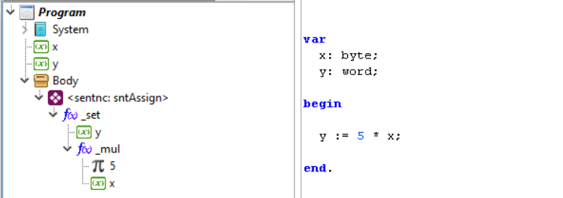

And since it is already a TAC, it will not be modified at this stage. But if the expression were a little more complex, such as "y := 5 * x + 1", its representation in the AST would be:

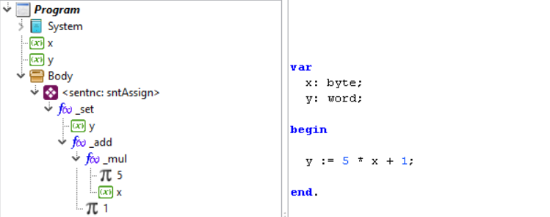

And since it is a branch more nested than a TAC, it will proceed to divide, until it is as follows:

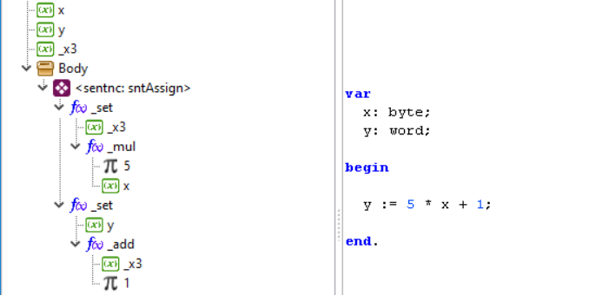

Which includes two TACs:

_x3 = 5 * x
and := _x3 + 1

This operation also required the creation of a temporary variable "_x3" that is declared in the AST as if it were a common variable.

A characteristic of assignment statements is that the last assignment TAC statement works with the variable of the original expression, which in our case is "and".

Later phases of optimized could simplify these TAC instructions.

Conditional sentences

Conditional statements (sntIF) include one or more conditions. These conditions are expressions and can also be simplified with TAC instructions.

For example, consider the conditional figure:

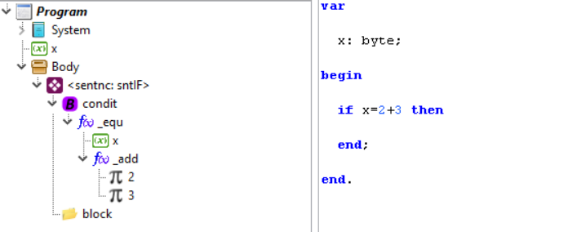

The expression of the condition "x=2+3" can be converted into two TAC instructions, and would look like this:

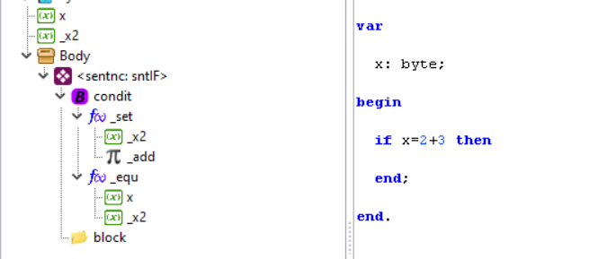

In this case, the expression of the condition, which is located in the node "condit" has been divided into TAC instructions, requiring a temporary variable "_x2".

The particularity of the TACs generated in the condition of a conditional, is that the last TAC is the final condition that must be evaluated, which in our case is "x = _x2".

Logically if the condition is very simple as "x>2", or something like that, it is represented as a simple CT scan and does not require separation.

Call to procedure statements

Procedure call statements (sntProcCal), which consist of a single call to a procedure, after analysis are as follows:

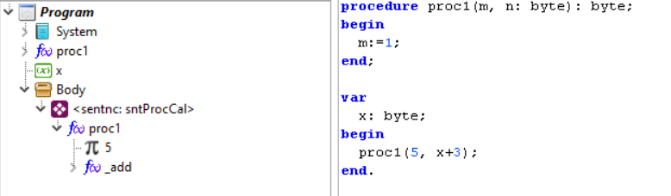

In this form, the procedure is the parent node and the parameters are included as child nodes. In this way, each parameter can be at the same time a complex expression.

In this case, simplification consists of generating an assignment statement for each parameter of the procedure, before the call to the procedure:

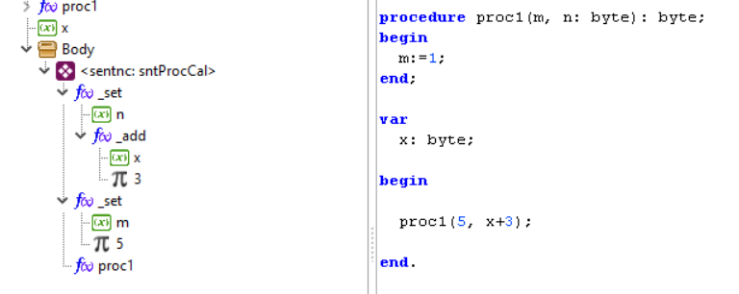

Procedure call statements always end with the procedure call.
Previous assignment statements can also be optimized, as if they were common expressions.

Procedures that are functions can also be used as part of expressions, as in the following case:

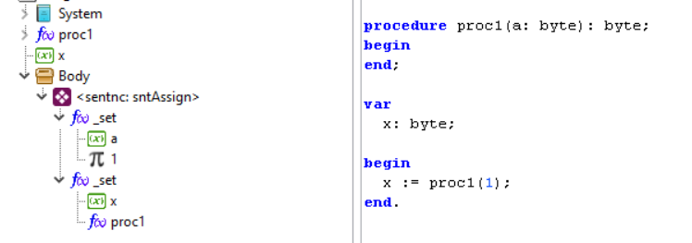

Notice the difference with INLINE methods:

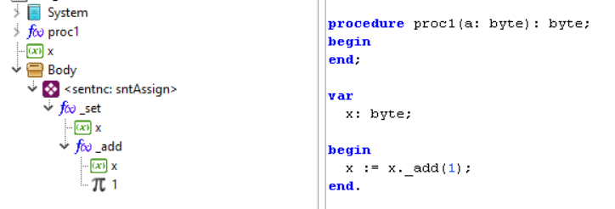

INLINE functions or methods maintain their parameters as child nodes while common functions include assignment operations before the function call.

The problem of requirements detection

One of the optimization tasks (which would normally be done in a linker) is to determine the functions that should really be compiled, because otherwise we would have to compile all the existing functions which would be totally inefficient (although very easy).

Requirements detection

Currently the requirements are defined in the AST, and are detected when analyzing the instructions of a function or the body of the main program.

Consider for example the following program:

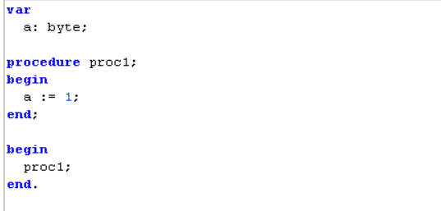

Here it can be easily seen that the proc1() function has as a dependency the variable "a" and that the main program has proc1() as a dependency, because that information can be extracted from the same program and will also be reflected in the analysis process.

The compiler detects these dependencies in the optimization phase and thus decides which elements should or should not be created in memory.

One way to determine dependencies is to use the code explorer and select the properties window:

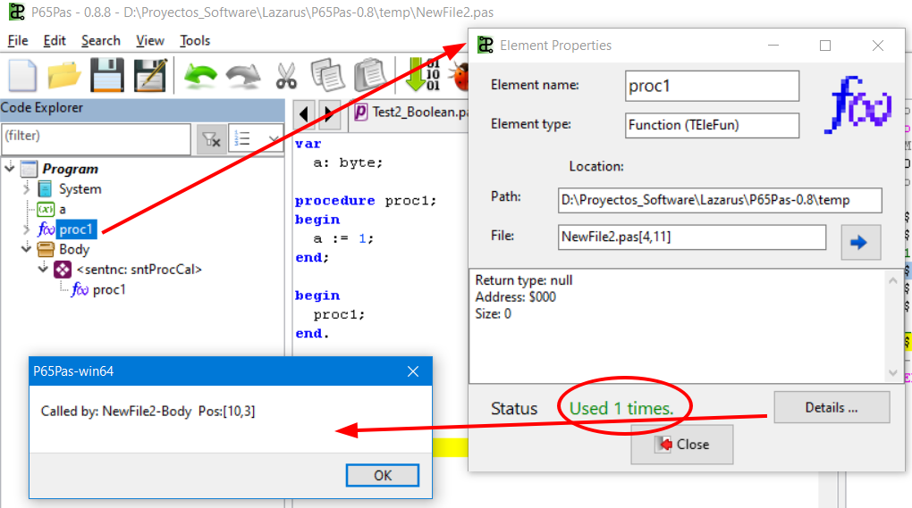

Another way to view dependencies is to use the "List report" from the "Tools>" menu.

Requirements in system functions

This form of requirements detection works well for user-defined functions because they are defined with source code where it is easy to detect dependencies.

But system functions, those that are created internally within the System drive, cannot generate dependencies directly in the source code.

To do this, it has been established that the dependencies are also created at the time of creating the function within the System unit, called AddCallerToFrom().

This method can be observed in TGenCod.CreateSystemElements() in the case of the INLINE function Byte._mul().

The section that creates the INLINE function is:

procedure TGenCod.CreateSystemElements;
...
f:=CreateBOMethod(typByte,'*','_mul', typByte, typWord, @BOR_byte_mul_byte);
f.fConmutat := true;
f_byte_mul_byte := f;
...

Then having the reference of the INLINE function in "f_byte_mul_byte" the references are included in the final part of TGenCod.CreateSystemElements():

procedure TGenCod.CreateSystemElements;
...
//Add dependencies of TByte._mul()
AddCallerToFrom(f_byt_mul_byt_16, f_byte_mul_byte.bodyNode);
AddCallerToFrom(f_word_shift_l, f_byte_mul_byte.bodyNode);
AddCallerToFrom(H, f_byte_mul_byte.bodyNode);
...

Here it can be seen that it is being indicated that if the method Byte_mul() is used, which is easily detected by the analysis routines when the operator "*" or the method _mul() is found, the dependencies to are included:

The f_byt_mul_byt_16 routine()
The f_word_shift_l routine()
The variable "H".

This part of the code is included at the end because you have to create the functions f_byt_mul_byt_16() and f_word_shift_l() first.

Note that calls with AddCallerToFrom() are made from the Body element of the INLINE function and this is a good reason that justifies why the INLINE functions of the system include a Body.

The problem

The described method, of including dependencies in CreateSystemElements(), works well with system functions while standardizing requirements management, because they are now fully detected in the analysis process.

This approach, however, is not entirely perfect because there are cases in which the requirements will be included, but these will never be used.

These cases are:

CASE1: Calls to functions in blocks that will never be executed:

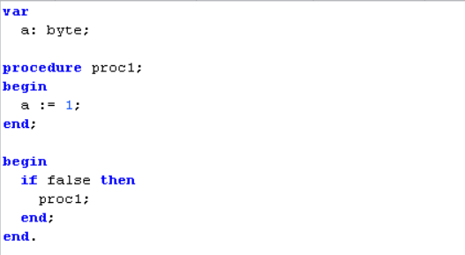

In this case, for example, the proc1() function will be detected as used but will never be used.

CASE 2: INLINE functions that never get to call your dependency:

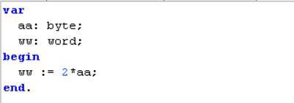

In this case, the INLINE routine is being called Byte._mul() that indicates that it has dependencies on the routines f_byt_mul_byt_16(),f_word_shift_l() to the variable "H". However, when analyzing the compiled code, we will see that the routine generated for multiplication never called any routine because it was optimized as a simple scroll operation.

To overcome that problem, a "cmRequire" compilation mode was initially implemented that called the BOR and UOR routines only to detect the requirements. But this approach had the following problems:

- The cumbersome thing of having to define one more mode of compilation in all BOR and UOR routines.
- The optimal requirement was not always obtained because the scan in "cmRequire" mode could be different from the "cmGenCode" scan (operands could change in storage after some simplifications) and functions that were ultimately not used or the reverse case that was worse have been compiled.

This maintains the current form of dependency detection, described in sections 10.6.1 and 10.6.2, with the aforementioned problems (which always work, although they are not always efficient) because a better way of implementation has not been found.

One solution envisaged was to include a subsequent routine that detected unused requirements and recompile everything back to exclude those unused items. But to date, nothing similar has been implemented.

Another, more radical solution would be to change the scheme completely and generate reusable code leaving the linker the task of identifying the functions used.

SYNTHESIS

The Synthesis, which consists mainly of code generation, no longer focuses on details of syntax analysis, or error detection, which were already verified in the analysis and optimization process.

The only errors that are expected to be detected at this level are:

- Full memory or some overflowing hardware resource (such as the stack).
- Routines not implemented in the compiler. This is common considering that not all cases are supported by the code generator.

As the Synthesis is made from the AST, which contains the location, in the source code, of each syntactic element, it is possible a precise location of some error, in case it occurs, and of course, that it is associated with a location in the source code.

In the process of generating code, by a compiler, you usually have two independent processes:

- The compiled to object code.
- The linking to machine code.

In P65Pas, code generation is attached to the binding process. There is no separate binding process, but it is the same compilation routines that are used to build the final code.

Problem of Code Generation.

A typical compiler compiles all of a project's code, including unused code, and leaves the work of reordering the code, in the most efficient way, to a different process called a linker.

P65Pas does not use linked, because:

- To use linker, the compiled code would have to be relocatable and this would require drastic modifications in the code generation.
- By optimization, it is avoided to generate relocatable code.

Now as the machine code of a subroutine (or the main program), can be different, according to the position where it is located (A typical case is when it is compiled for page zero or not), the generation of code must be done in the final location.

But to have the final location, it is necessary that all the variables, to be used, are already located in RAM, however the generation of code may also require other auxiliary variables (which could need to be on page zero), which would move the final location of the code that is being compiled.

To work around this problem, the compiler has been designed so that all dependencies of variables or functions can be extracted directly from the AST, using the process of identifying "callers", as explained in section 10.4.

However, despite being able to identify all the elements that "could" be used in the program; it is not possible to fully discriminate against the elements that will actually be used (See section 10.6).

Requirements

The requirements in the implementation of the code generator are:

- Achieve an efficient generation of code, in terms of space and speed, considering the limitations of hardware.
- Be oriented to the use of registers, since the architecture of the 6502 does not lend itself to the implementation of stacks.
- Create a clean, solid and easy-to-maintain design.
- Directly generate native code, without the need for external assemblers and linkers.

Creating variables

Creating variables involves assigning them an address in RAM. This process is developed by applying the reuse of the local variables of the functions, described in section 8.8.

Code Generator Units

Within P65Pas, two main points are identified, where machine code is generated:

- Unit "GenCod_PIC16" -> Here the code for the evaluation of the BOY and UOR routines is coded. The lexical analyzer is not accessible here.
- "GenCodBas_PIC16" unit -> Include basic initialization routines, instructions, and code scan routines.

It can then be said that, the generation of code is done for:

- Implement the Operation Routines. (Most of it)
- Implement conditional and loop structures.
- Implement additional control routines.

Use of Records

Work records are defined while Optimizing and Synthesis is being developed, but they must be fully defined before code execution. This means that for the program there are no surprises, in that unforeseen memory space is required.

This is possible, because no recursion (neither normal nor circular) will be implemented, and therefore there is no dynamic memory requirement.

The following diagram shows the use of work, auxiliary and stack records within the evaluation of an expression.

Opera(X,X)->X

Opera(k,X)->X
Code Generator

Opera(v,v)->X

Opera(k,k)->k

With
A
Work Records

C

H

Records assists res
aux1
aux2
aux3

lastASMcode,
lastASMaddr,
AcumStatInZ,
...
Expression variables

The shaded area indicates the use made of the indicated records. Records A, Z and C always exist, but the use made of them depends on the code to be implemented.

In general, we can say that all records cease to be used, at the end of the expression, except for the work records, which are precisely the ones who return the result of the expression.

The work records also serve to return the results of one underexpression to another, therefore, their life span passes between subexpressions, as can be seen in the figure.

The auxiliary records are defined as they are needed, in each subexpression. They only have one life cycle at the underexpression level.

Expression variables are compiler variables that allow information to be passed between calls to ROPs within an expression. That is, they have a life cycle at the level of expression.

These variables store important information, such as the use of flags, which is used to optimize code generation.

Work Records (WR)

In this section, only the case of work records at the end of subexpressions will be discussed. To see the handling of work records at the end of expressions, see section 11.6.2.

Almost always, work logs will contain the result of the last underexpression or expression:

The WRs contain the result
The WRs contain the result

Subexpresión
Subexpresión
Subexpresión

However, to be accurate about the use of work logs, one must take into account the type of operand, and the storage of the operand to be returned.

The following table summarizes the status of the work logs, at the end of a subexpression.

SUBEXPRESSION STORAGE | STATUS OF THE WRS, AT THE END OF THE SUBEXPRESSION
stConst | They were not used. They may be free or busy. But if they are busy, they are not for the last underexpression.
stRamFix | They were not used. They may be free or busy. But if they are busy, they are not for the last underexpression.
stRegister | They were used, and contain the result of the last underexpression. If the last subexpression was:  - Boolean, Byte o Char -> Se usa A  - Word -> Se usa A y H  - DWord -> Se usa A, H, E y U  Work records not involved in the outcome may be free or occupied. But if they are busy, they are not for the last underexpression.

Therefore, when starting the code of a subexpression, you must:

- Determine, which records are going to be used, both for the evaluation and for the result.
- If work records are to be used, then you must:
  - Ensure that they have been assigned, otherwise assign them.
  - Ensure that they are free, otherwise save their contents in the stack.
- If auxiliary records are to be used, then:
  - They must be created after you define the work records.
  - They should be released at the end of the operation routine.

Backing up work records

In the process of evaluating sub-expressions, it should not be the case of having to save the work records (WR), because the Optimization process must avoid these cases. If not, it is that he has not done his job well.

In previous versions of the compiler, if such cases could occur and additional routines had to be generated, to ensure that the value of the WRs in the evaluation of subexpressions is not lost.

Work Records at the end of expressions

The use made of the work records, when the expressions are finished, will depend on the location of the expression.

It is generally assumed that work records will contain the result of the expression, at the end of it.

Use of Work Records

Work logs are used to:

- Return the result of an underexpression.
- As an auxiliary variable in intermediate calculations. This is useful because you don't need to create temporary variables, and also because:
  - It is very likely that the WRs have already been used and would be reused.
  - WRs are mainly created on page zero, and they are quite fast.

When some Synthesis routine requires making use of a WR, for whatever reason, it does so as it would be done with any variable; a call is added to indicate that this variable will be used:

...
AddCallerToFromCurr(IX); //We declare using IX
_LDA(fun.rvar.addr);
_STA(IX.addr);
_LDA(fun.rvar.addr+1);
_STA(IX.addr+1);
…

The preceding snippet of code corresponds to the TGenCodBas.byte_LoadToRT() routine that makes use of the __IX work record. The AddCallerToFromCurr() statement logs a call to the IX record, so you will know that RAM must be assigned to this record.

Conditional

As described in the document "Documentation – Foundations and Analysis", conditionals are added in the AST as pairs <commonth>-<block>:

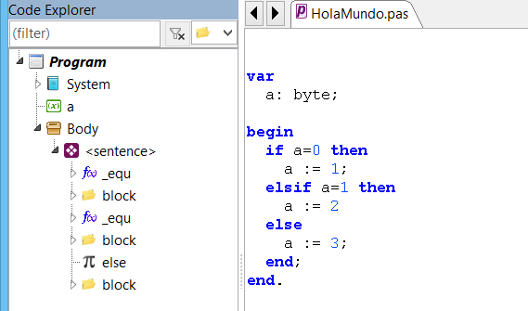

In addition, it was indicated that the ELSE statement, if it existed, was encoded as a conditional: "IF true THEN", for ease of synthesis.

For the process of generating code, and considering the conditionals as a set of pairs <commony>-<block>, a couple of rules are defined:

1. Pairs <commonth>-<block> with constant condition: "IF FALSE", are ignored.
2. Pairs <commonth>-<block> after a constant condition: "IF TRUE", are ignored.

The implementation of these rules is located in TGenCodBas.GenCondeIF()

Assembler Blocks

Assembly blocks are one more type of statement (sntAsmBlock) and are therefore processed in TGenCodBas.GenCodeSentences().

The code generation routine for assembly blocks is relatively simple, considering that the synthesis process already did a great job identifying the assembly instructions and coding them appropriately in the AST.

What remains to be done is to simply assemble the instructions according to the OpCodes and operands defined in the TEleAsmInstr elements that appear within the TEleAsmBlock elements:

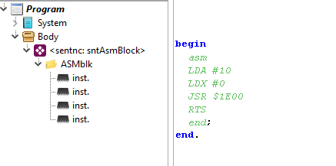

For detailed information on the analysis and filling of the AST with the assembly blocks, review the document "Documentation – Fundamentals and Analysis".

The routine used for generating code from an ASM block is TGenCodBas.GenCodeASMline(), and it is not very complex. Follow the scheme:

- Identify instruction type
- Read by operating
- Apply operations on the operand
- Encode instruction

A detail that must be considered when generating the instructions, is for the case of the operand label instructions, which have not yet been defined.

This is the case of, for example:

JMP code
LDA #0
Code:

Encoding the "JMP code" statement will not be able to define the exact value of the jump, because the tag statement will be processed later.

In this case what is done is to complete the instruction with a tentative operand (See ReadOperandValueRef), and then be completed with the real value.

The completion of the final value of the operand of the instructions of this type is done with the help of the "undefInstrucs" list of the ASM block (TEleAsmBlock element) that is being encoded.

The "undefInstrucs" list is populated in the scanning process with the list of instructions that need to be completed later. It is used in code generation because here you will also need to complete the undefined operands.

This process can be observed in TGenCodBas.GenCodeSentences().

procedure TGenCodBas.GenCodeSentences(sentList: TxpElements);
...
begin
for eleSen in sentList do begin
...
case sen.sntType of
sntAssign: begin //Assignment
...
end;
sntProcCal: begin //Call to function or method
...
end;
sntAsmBlock: begin
asmBlock := TEleAsmBlock(sen.elements[0]); //Takes root node.
for ele in asmBlock.elements do begin
inst := TEleAsmInstr(he);
GenCodeASMline(inst);
end;
//Remains to complete uncomplete instructions
for inst in asmBlock.undefInstrucs do begin
pic.iRam := inst.addr; //Set at its original RAM position
GenCodeASMline(inst); //Overwrite the code to complete
end;
end;
...
end;
if HayError then exit;
end;
end;

Assembly Code Generation

Unlike other compilers, P65Pas is a compiler that directly generates the binary code (*.hex file), bypassing the assembly code stage.

This technique has the advantages that:

- It performs the entire code generation process in a very short time.
- It does not require any additional software for the compilation and that does not require implementing an assembler of its own.
- By being closer to binary code, the code generator can easily add debugging information.

On the other hand, the disadvantages would be:

- The implementation of the code generator is more complex than using a separate assembler.
- You don't have some kind of intermediate code representation to verify code generation.

However, that does not mean that P65Pas, can not get an assembly code of the generated program. Since the first P65Pas versions, it has always worked with an additional window to display the assembly code of the compiled program.

But this assembly code is generated by the reverse path. Using binary code, directly.

Assembly Code

Binary Code

Source code

The binary code is stored directly in a structure offered by the P6502Utils library, which corresponds precisely to the model of a virtual PIC, which is used for simulation.

So that the assembly code can be generated with additional information, the code generator includes in addition to the binary code, comments and tags associated with memory positions.

The insertion of additional information to the binary code and the extraction of the assembly code from the binary code are options that correspond more to the P6502Utils library than to P65Pas code.

POLICIES

The management of directives is a topic elaborated within P65Pas. In part, because the definition that is made of the directives, is quite complete (that's why there is a special unit for it), in comparison, with other compilers.

Policy Processing

The policy processing routine is called from TCompilerBase. ProcComments.

Policies are processed at compile time, more strictly on the first pass. And that poses an additional problem because:

- Binding units (code blocks, which bind independently) are procedures, while directives can determine separate blocks, such as blocks that are created when using {$IFDEF} ... {ENDIF}, which can cover more than one procedure:

program number;

procedure proc1;

begin
Linking block
something
{$IFDEF aaa}

end;
Policy block
procedure proc2;

begin
Linking block

something

end;
{$ENDIF}

begin
end.

- Policies are processed linearly in code, so the outcome of a policy can be influenced by the previous one. On the other hand, the link will only compile some procedures, being able to stop processing blocks that contain directives.

program number;

procedure proc1;
Procedure that will not be linked
begin
{$DEFINE aaa}
end;

procedure proc2;
Procedure to link
begin
{$IFDEF aaa}
something
{$ENDIF}
end;

begin
end.

Basically, the problem is in solving conditional directives, in binding, because in the first pass, the processing is linear and there are no problems.

To solve the problem, a second syntax tree is used, (TCompilerBase.TreeDirec) that is populated with nodes, at each point where a directive that returns a result is located, such as {$IFDEF ...} and {$IFNDEF ...} . This filling is done only in the first pass, and saves the result of the conditional directive, so that in the second pass, only the corresponding node is accessed (searching by location), to see what value it gave in the first pass, and not to make a new evaluation, which could be erroneous.

The use of this technique can be seen, for example, in TParserDirec.ProcIFDEF(). In this way, the problem of policy resolution has been solved, without problems reported to date.

The language of policies

The directives in P65Pas go beyond simple symbol declarations and their verifications, as is done in other compilers.

Within P65Pas, the directives handle another programming language, other than Pascal, and departs a bit from the common compiler directives, such as Turbo Pascal or Free Pascal.

Although the language is simple, it contains well-defined structures.

To begin with, the language is not typed and is processed as a script, using an interpreter.

INSTRUCTIONS
Within Pascal code, policy statements appear between the delimiters: "{$" and "}", and can only occupy one line:

{$ <policy instruction> }

It is not necessary to put a delimiter to the instruction, because the character "}" always delimits any instruction.

DATA TYPES
Only two types of data are handled:

- Numbers. They are defined with variables or literals such as: 123, 5.24, -21 or 0x20
- Chains. They are defined with variables or literals such as: 'Hello', 'Hi World'

VARIABLES
It is not necessary to declare them. They can change their type, in the middle of the program.

Declares and assigns to a numeric variable
{$SET x = 1}

Assign new value to "x"
{$SET x = a + b}

Declares and assigns to a string variable
{$SET cad = 'I am a string'}

For more information on the language of policies, we recommend that you see the User's Guide.

SIMULATION

Simulator

Code simulation is an additional facility offered by the P6502Utils library, which is used in P65Pas, to implement a simulator/debugger, integrated into the same application.

The compiled code is stored directly in the virtual PIC offered by the P6502Utils library, and this is where the simulation occurs.

The simulation runs directly on the machine code and although it is quite complete to simulate the execution of instructions, it does not implement the various devices that include CIPs, such as timers or ADC converters.

Local variables are not fully implemented in P65Pas, and are only used for some internal functions.
These memory requirements are made in the same memory handler as the compiler. It is not that they are generated inside the CPU, during its execution.
Each compiler can define, according to design, how the result of the expressions are stored.
The possibility for the user to generate their own custom types with their corresponding operations (methods) is being contemplated. In that case, you might need to declare your own work records as additional variables that could be defined in a unit, which would also be used to define the custom type.
In the initial versions of the compiler, both fields were joined into one (field "Sto"), but handling this unique field considerably complicated the process of generating code.
This is the working method considered in the design of the P65Pas because it is not expected to support recursion, due to the limitations of the 6502's hardware.
Until the current version, all methods of the predefined types of the system are defined as INLINE functions, not as normal functions.
Although the generated code may include calls to other normal subroutines.
This feature may vary in future releases.
Not currently implemented.
Actually, all calls to any type of element to which it refers should be withdrawn, but so far it has only been implemented, for functions.
In reality, the implementation was never complete because it stopped as soon as the problems were glimpsed.
A re-localizable code is a code that could be located anywhere in the program memory, without changes or with minimal changes.
It is thus defined to try as much as possible to locate as many variables on page zero.
Assigning a work record involves allocating memory space to them.

